Issuing Practical English Registration Keys
Please follow the instructions in these screen shots to issue registration keys. Begin by logging in at http://ac.reallyenglish.com/aoyama/ .
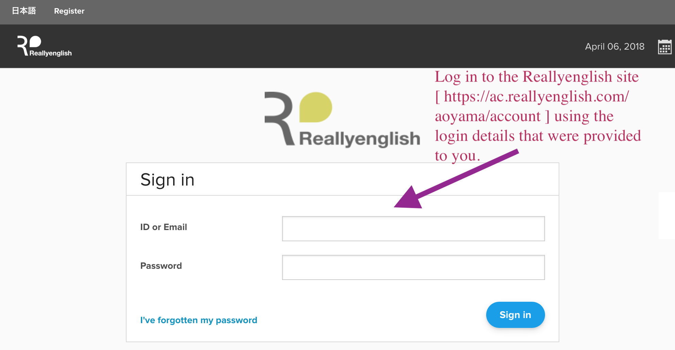
After logging in, click on the “Admin” menu, on the upper lefthand side of the window.
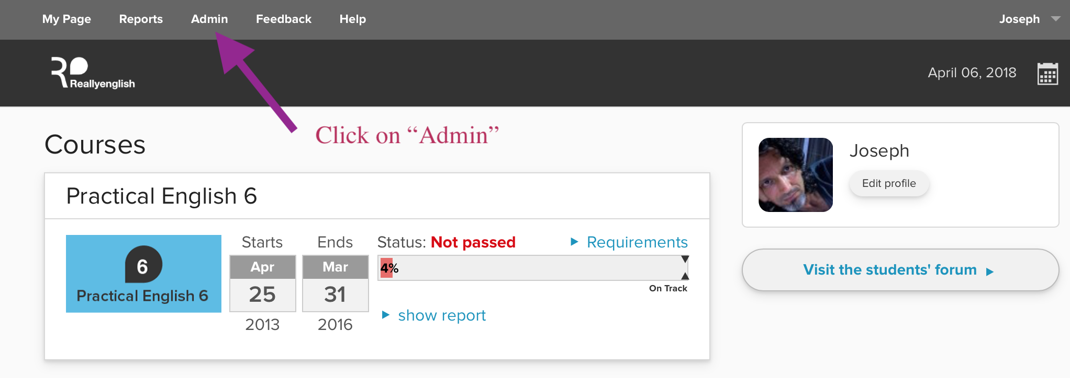

Then, click on “Issue Keys.”
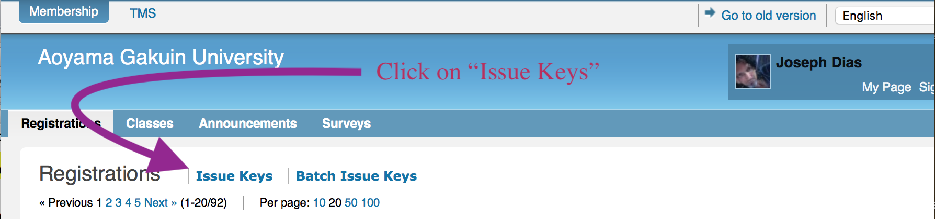
Next, set the number of registration keys that you require.
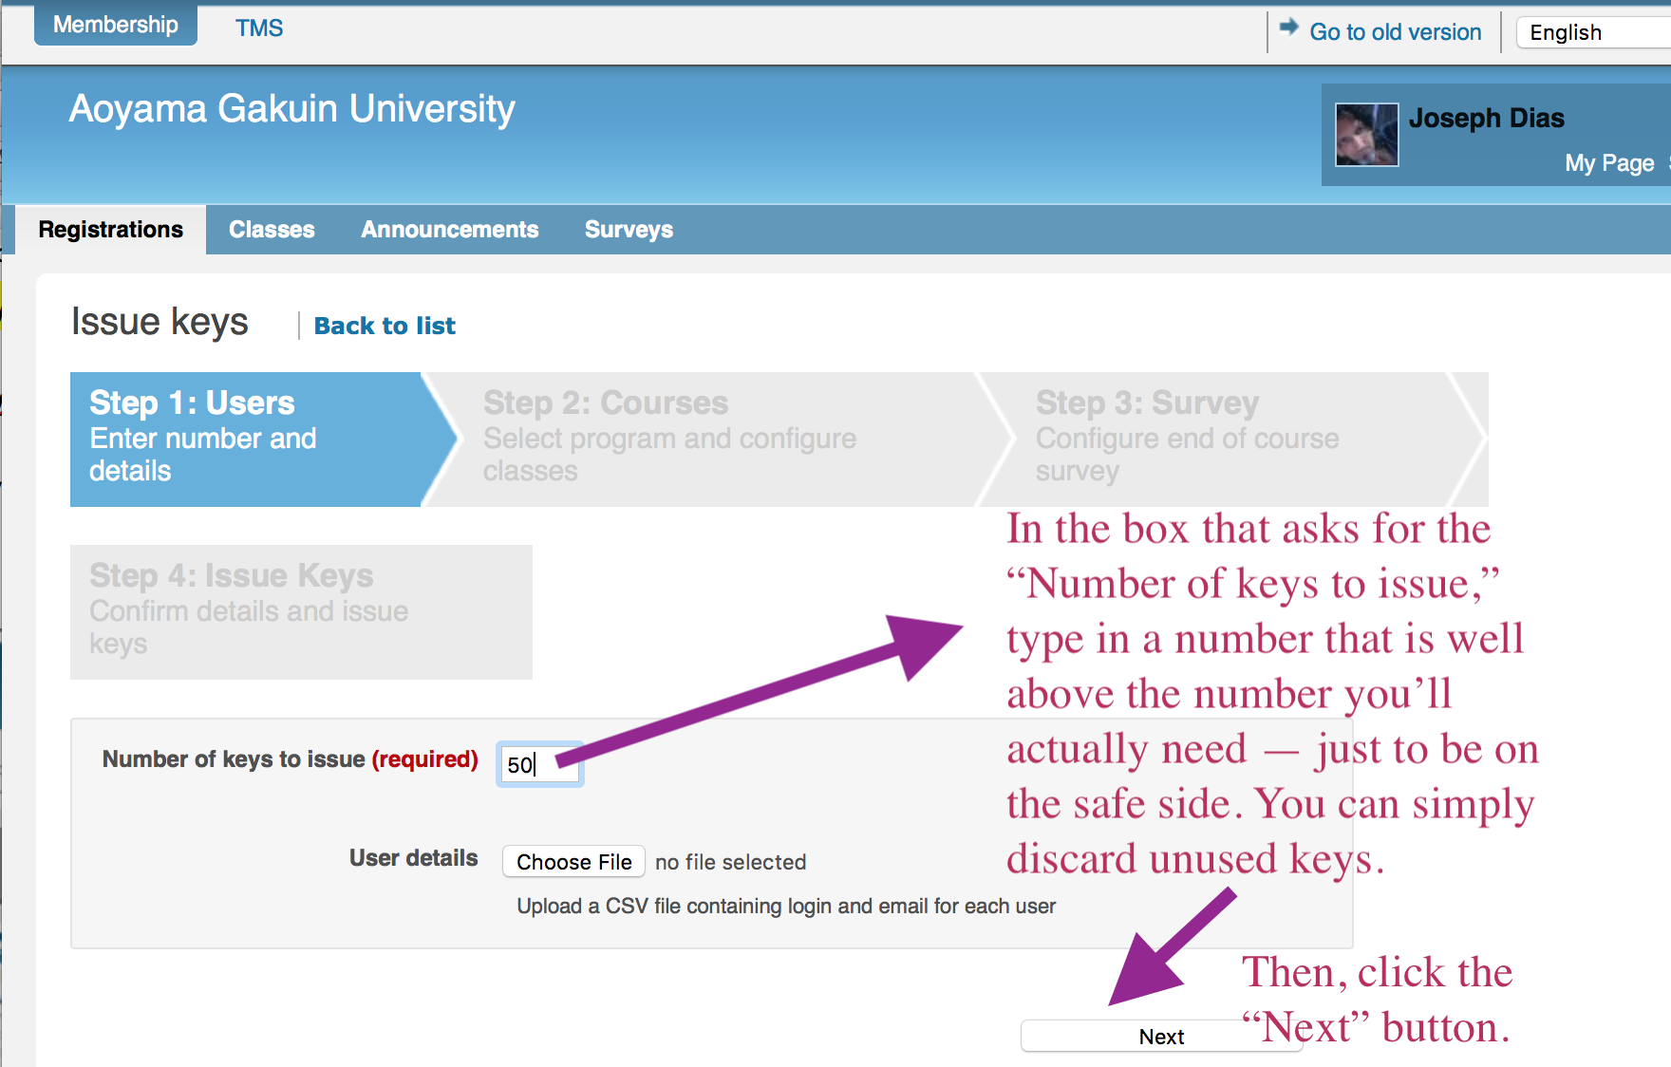

From a drop down menu which will appear, select the course and then click on the “Create new class” button.
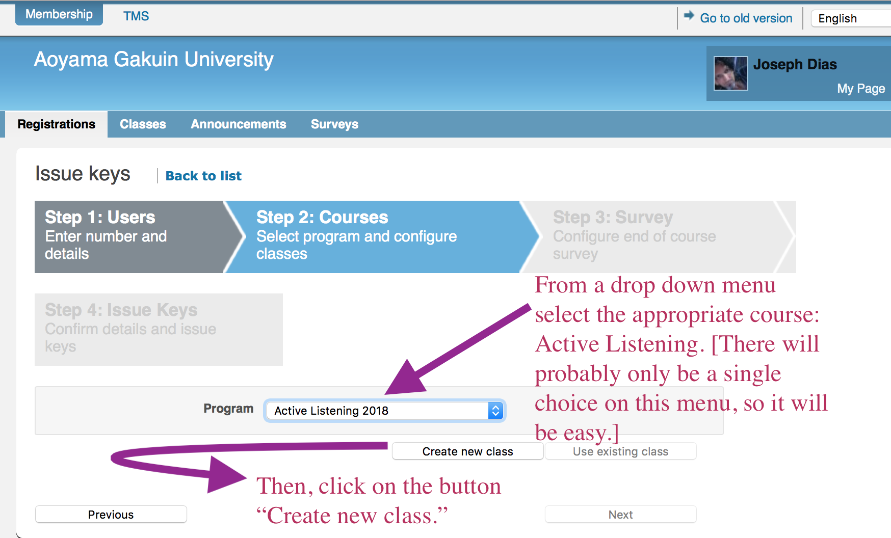
Then choose the appropriate level and current semester from the next drop down menu. After that, click on “Create new class.”
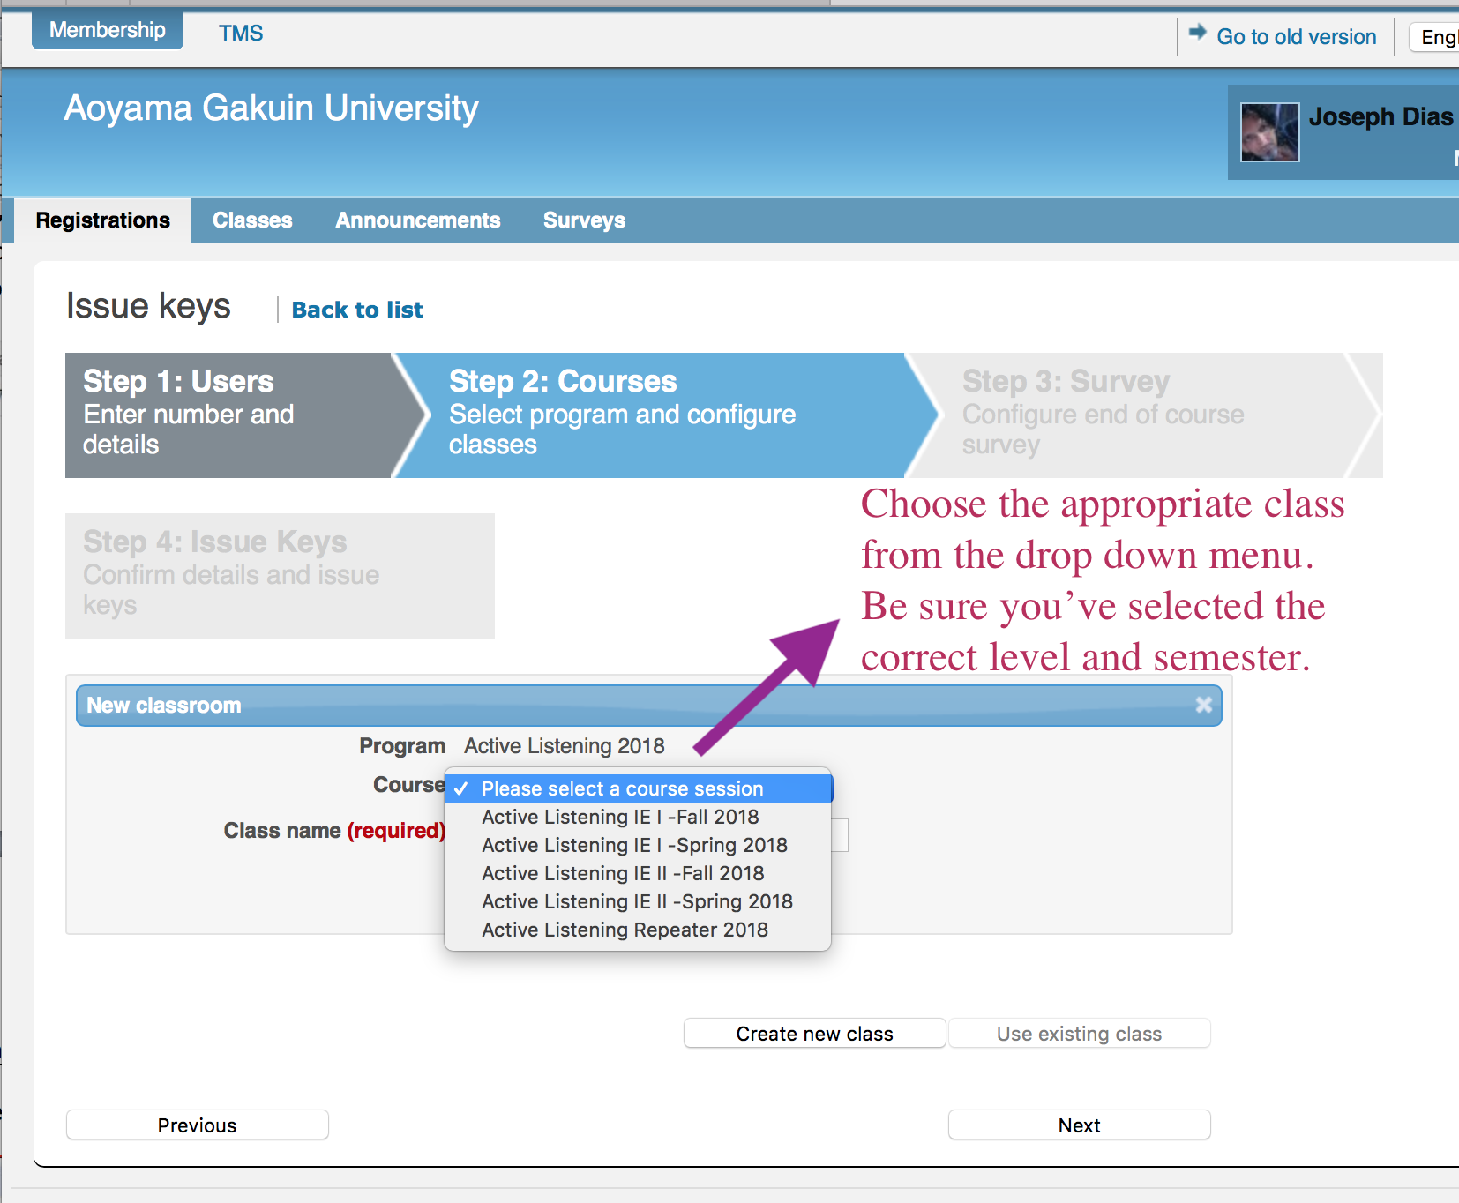
You will then need to create a name for your class by following the instructions in the screen shot.
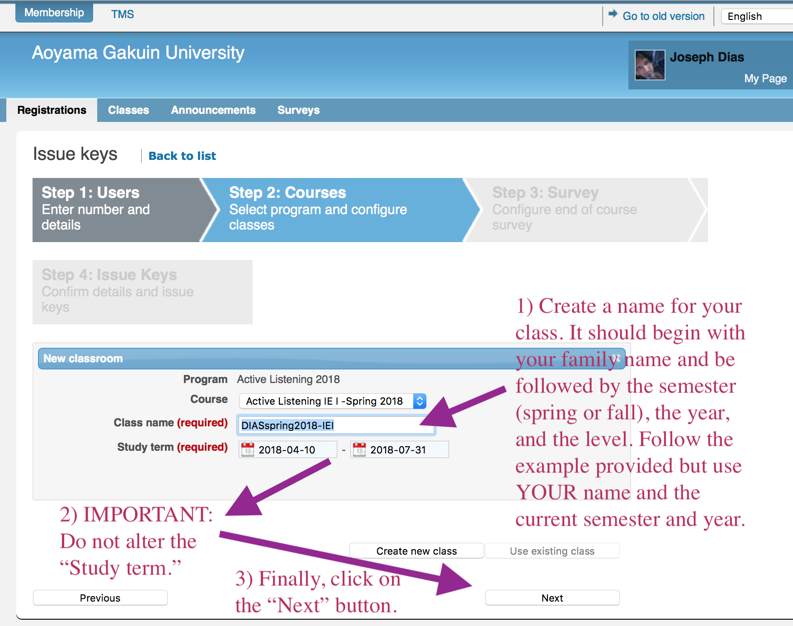
It is very important that you do NOT change the default period in the “Study term.” Finally, click on the “Next” button. In the following screen decline the invitation to create a survey.
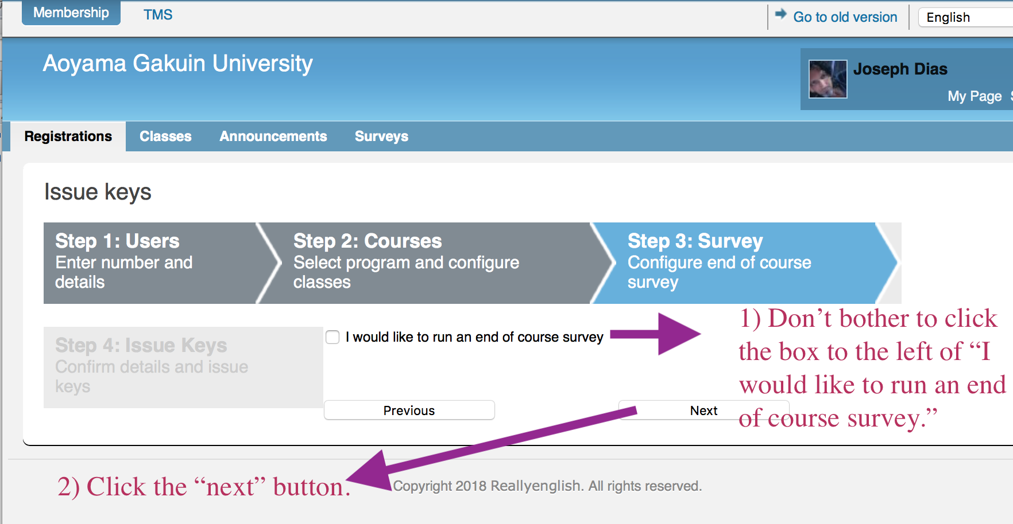
In the next screen you will be asked to confirm the information that you submitted previously. If it looks all right, click on the “Issue keys” button.
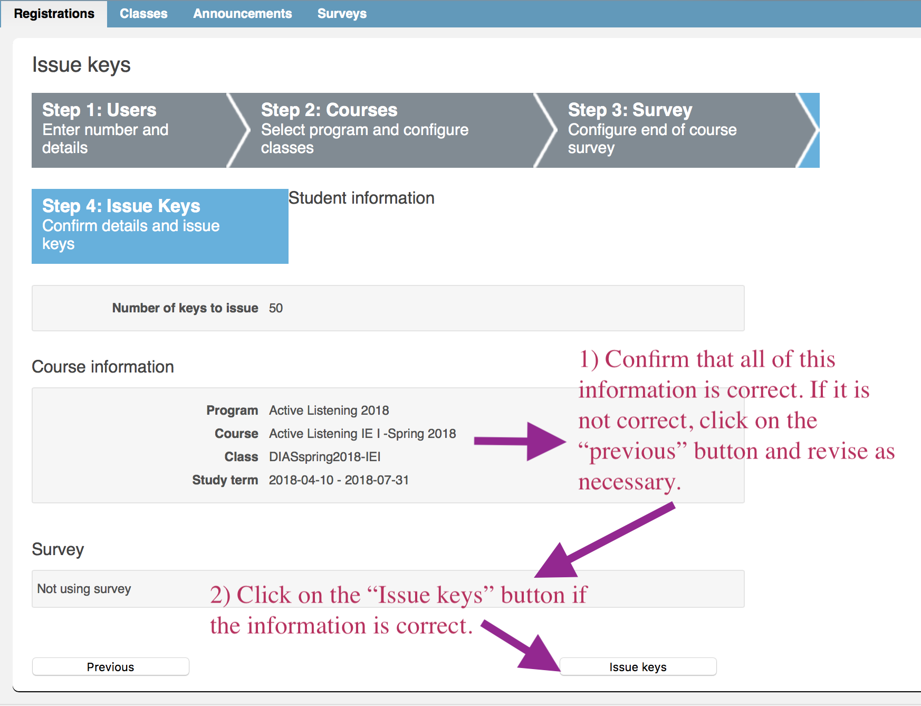
Download the registration keys by clicking on the “Download details” button.
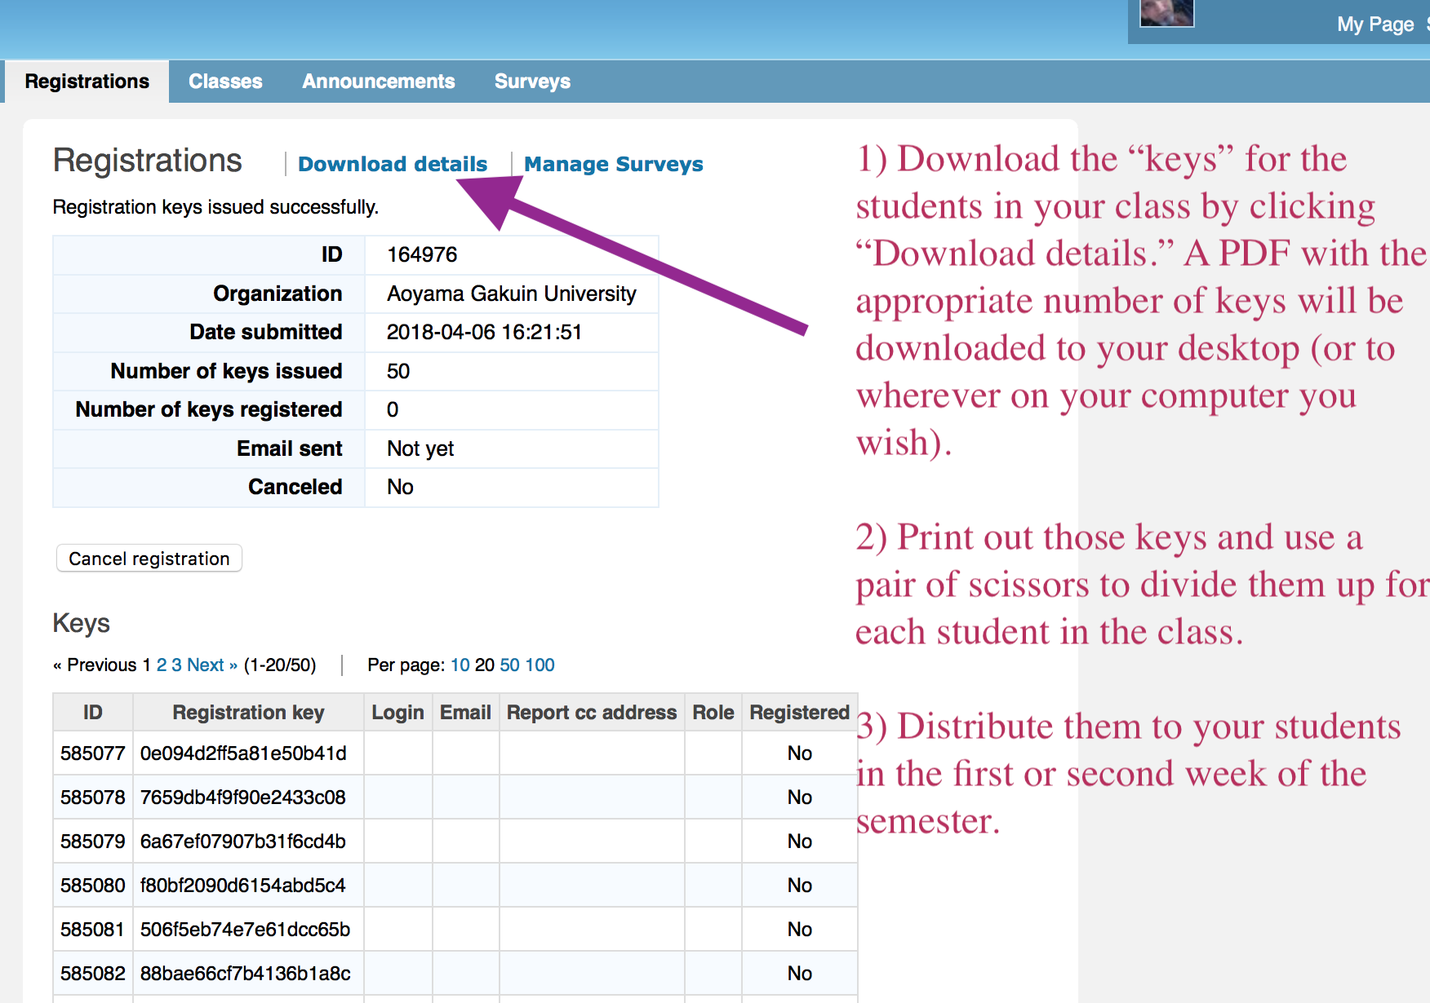
Print out the PDF of the keys and then cut up the unique keys, using scissors, for each of your students.

