OE 1 and OE 2
Scope and Sequence
2016

Overview of the OE Courses ………………………..  OE 1 Course Description ……………………………  OE 2 Course Description …………………………… | 2  6  8
Appendixes:  Small Group Discussions ……………………………  Sample Newspaper Summary ……………………….  Teaching Vocabulary ………………………………..  Assessing Discussions ………………………………  OE 1 Poster and PSA/CMs ……....………………….  OE 1 Student Interview Projects ……...……………..  OE 2 Group Presentations……...…………………....  OE 2 Debates and Documentaries ………………......  Sample Course Outlines ……………..……………... | 12  23  26  31  33  41  44  52  60

The OE Guide was developed by Gregory Strong with contributions from Joseph Dias, and OE teachers, including Melvin
Andrade, Deborah Bollinger, James Broadbridge, Loren Bundt, Keiko Inouye, Trine Mork, Kazuko Namba, Barnaby Ralph,
Todd Rucynsky, Eric Shade.

Copyright, March 6, 2016, Gregory Strong, Aoyama Gakuin University
OE 1 Goals and Evaluation
Course Goals
1) To improve students’ confidence in using English for communication;

2) To improve students’ skills in speaking, reading, listening, and writing, mainly
through the small group discussion task;

3) To assist students in becoming more autonomous language learners through
project work such as the interview project, poster session, or PSA/Commercial;

4) Through demonstration in class, provide students with examples of
Communicative Language Teaching (CLT), as well as how language teachers
choose appropriate tasks for language learners such as the small group
discussion project, vocabulary notebooks, and other classroom tasks.

Teacher Use of Textbooks and Materials
Ideally, any course textbook should be at the lower intermediate level and provide reading, listening, and student writing activities that lead to speaking tasks. Teachers may, of course, use their other materials if they fit this description.

Suggested Text:
1) Richards, J., Hull, J., Proctor, S.(2013). Interchange 2. (4th ed.). Cambridge
University Press: Singapore. [The book integrates speaking, reading, listening,
writing, provides vocabulary and grammar activities and comes with a self-study
DVD rom, MP3s of the class audio program, access to Interchange Arcade, and
an online workbook.]

Suggested Evaluation
• Serving as Discussion Leader and news summary writing 40%
• Vocabulary notebook 15%
• Interview/Poster Project/PSA or Commercial 25%
• Vocabulary and reading tests 15%
• Class participation 5%

OE 1 Tasks
1 (Term 1)
• Small Group Discussion
of a News Item

- Introduce self, use others’
names, make eye contact,
gesture to communicate

- Turntaking, agreeing,
disagreeing, giving reasons,
clarifying

Choose a news item from a newspaper, or an online source:
- orally summarize it
- express an opinion about it
- solicit other opinions about it
- ask follow-up questions

Write a response to the item:
- note the source in APA Style
- choose 5 vocabulary words
- take notes on the article (who?
what? where? when? why, how)
- use the notes for a summary
- use a quotation for the summary

3(a) (Term 2)
• Interview Project leading
to a Poster Session
- Find a native speaker of another
language, or a returnee, and
interview them about language
learning, or cultural differences
- Transcribe the interview, take notes
- Create a poster of visuals and text
2
• Vocabulary Notebooks
- collect vocabulary words
- write definitions and create
sentence examples
- review the words with partners

3(b)
• Poster Session
- Research a topic
- Create a poster of visuals and text
- Participate in a ‘poster carousel’ in
which half the class explains their
poster to the other half

OR
OR
3(c)
• PSA or Commercial
- write and rehearse a 1-2 min. script
- create a storyboard with sound
cues, and basic camera angles,
close-up, medium shot, etc.
- film and edit a short video

OE 2 Goals and Evaluation
Course Goals
1) To improve students’ confidence in using English for communication;

2) To improve students’ skills in speaking, reading, listening, and writing, mainly
through the small group discussion task;

3) To assist students in becoming more autonomous language learners through
project work such as the group presentation or debate;

4) Through project work, extend English skills into public speaking, developing
arguments, or utilizing media.

Teacher Use of Textbooks and Materials
Generally, a multi-skills textbook at the intermediate level with reading, listening, and student writing scaffolding speaking tasks. Teachers may use other materials.

Suggested Text:
1) Richards, J., Hull, J., Proctor, S.(2013). Interchange 3. (4th ed.). Cambridge
University Press: Singapore. [The book integrates speaking, reading, listening,
writing, provides vocabulary and grammar activities and comes with a self-study
DVD rom, MP3s of the class audio program, access to Interchange Arcade, and
an online workbook.]

Suggested Evaluation
• Serving as Discussion Leader and news summary writing 40%
• Vocabulary notebook 15%
• Presentation/Debate/Short Documentary 25%
• Vocabulary and reading tests 15%
• Class participation 5%

2 Tasks
3(a) (Term 2)
• Group Presentation
- It could take the form of a
presentation of a survey, role
play, or a debate
- Research, organize information
- Public speaking skills, use of
audio-visual aids

1
• Small Group Discussion
of a News Item (Term 1)
- Greater variety of turntaking
language than in OE 1
- Introduce self, use others’
names, make eye contact,
gesture to communicate

- Turntaking, agreeing, clarifying
disagreeing, giving reasons,

Choose a news item from a paper, or an online source:
- orally summarize it
- express an opinion about it
- solicit other opinions about it
- ask follow-up questions

Write a response to the item:
- note the source in APA Style
- choose 5 vocabulary words
- take notes on the article (who?
what? where? when? why, how)
- use the notes for a summary
- use a quotation for the summary

3(b)
• Mini-Debate
- Prepare an argument
- Learn the basic argument types
- Familiarize one’s self with the
debate format
- Present an argument with
quotations and paraphrases
- Judge a debate

OR
OR
3(c)
• Short Documentary
- write a commentary
- subtitle any Japanese language
- create a storyboard with sound
cues, and basic camera angles,
close-up, medium shot, etc.
- film and edit a short video

2
• Vocabulary Notebooks
- collect vocabulary words
- write definitions and create
sentence examples
- review the words with partners

ORAL ENGLISH 1 & 2
The Oral English 1 and Oral English 2 (OE 1, OE 2) courses are pre-requisites for students in the departments of Education, French, History, and Japanese Literature, and Psychology. At the same time, the OE courses are a requirement for students who wish to obtain a teaching license, so we have an obligation to explain something of Communicative Language Teaching and learning tasks. At the same time, the students in these classes show a range of language abilities and exhibit less motivation to study English than the English majors we usually teach, so high interest materials are essential.

At the same time, OE teachers will likely find that their classes are often less academically than students in the English Department, so teachers need greater freedom to choose appropriate content. However, you must frame your classes in terms of the 3 main tasks for each of the two OE levels. Teachers may choose one of three different tasks for the Fall semester of their classes. An alternate task is also a possibility if it includes a strong language component and a use of speaking, listening, reading, and writing.

ATTENDANCE AND GRADING
Please make it clear to students that missed classes or tardiness will affect their grades. This scale is for year-long courses such as Oral English or electives:

Absences | Maximum Grade
2 | * No effect on grade
4 | Final grade cannot exceed 89%
6 | Final grade cannot exceed 79%
8 | Final grade cannot exceed 69%
10 or more | Fail (unless legitimate absences)

At the same time, assess your students on several different aspects of the course. For example, they should be given a grade for each of their discussions (both the written work as well as their oral discussion in class), participation in class, their vocabulary notebooks, and some form of vocabulary test or assignment, and their term 2 task.

ORAL ENGLISH 1
1) Weekly Small Group Discussions (First term)
We expect teachers to organize small group discussions of 3 or 4 students, so that in a class of 24 students, there will be 6 or 7 different groups involved in discussions in each class. Each group should have a discussion leader.
Before class, the discussion leader summarizes a newspaper article, or on-line news article and prepares 3 or more discussion questions. (See Appendix 1 for a full description of the task and classroom preparations).

The discussion activity should be introduced in the first OE class and explained using the exercises and methodology found in Appendix 1. There is a sample sign-up sheet for students in Appendix 1.

In class, the discussion leader facilitates the discussion by describing the article without reading from notes and by questioning his or her partners. Because the leader will present the same discussion to three or four groups, gradually, the discussion leader will speak more fluently and confidently. Generally, each discussion should take about 10-15 min. The teacher should move all the discussion leaders to a new group after that time.
This enables each student leader to describe his or her news story to a new group of students. Moving the leaders three times will take about 45 minutes of class time with a class of about 25 students.
Each student should be a leader of 3 discussions each term.

After leading a discussion, the student submits a newspaper summary to the teacher. It should include information about the time and source of the article according to the APA style, (a)who the story concerned and (b)what it was about, (c)where it took place, (d)when it occurred, (e)why it’s important, and (f)how it happened, and an opinion in which the student describes their feelings about the event. The teacher should evaluate the summary and the discussion leader’s performance. (See Appendixes 2 and 4.)

2) Vocabulary Notebooks
Students should make weekly entries in vocabulary notebooks recording some 10 new words discovered in each class or in preparation for a discussion. Besides noting the new words and their definitions, students should create an original sentence for each word. (See Appendix 3 for suggestions for introducing and reviewing vocabulary in class).

3) Option 1# Interview Project (Second term)
In brief, there are several ways to approach the interview project. One is to start with students interviewing you. Then they can interview their classmates who may have travelled or lived abroad. Interviewing a guest speaker in the class is another good resource for this project. Different groups of students might be responsible for a different series of questions on a single theme suggested by the guest speaker’s introduction or the contents of the guest speaker’s lecture. The themes could be assigned on a “first come, first reserved” or voluntary basis.

If you wish your students to interview native speakers outside of class, then the safest way is to accompany them on a fieldtrip, or even go with them to Shibuya Station and agree upon a finishing time and a meeting place. Other options are for students to interview international students or returnees on campus or to interview a native speaker they know. Doing interviews via skype or email are also possibilities. Alternately, you might give your students the option of doing a family history project about their grandmother or grandfather’s experiences living in Japan. Although students would be conducting the interview in Japanese, they should write their questions in both English and Japanese. Then the results should be translated and reported in English to another pair or to a small group in a subsequent class. Written summaries should also be collected by the teacher.

Please avoid harassing other teachers with your students’ interviews. Be aware too, that an interview project can quickly degenerate into students questioning native speakers by reading aloud from lists of questions and scribbling down answers. Adequate time should be provided in class for students to develop questions and to role play asking and answering them. Brainstorm different questions in class and avoid formulaic questions to ensure that your students have different questions. (Please see Appendix 6 for a detailed explanation). Todd Rucynski, Deborah Bollinger, and Gregory Strong have created an instructional DVD showing the development and presentation of student interview projects.

If you wish your students to interview native speakers outside of class time, then the safest thing is to accompany them on a fieldtrip, or even go with them to Shibuya station and agree upon a finishing time and a meeting place. Alternately, you might require your students to do a family history project about their grandmother or grandfather’s experiences living in Japan. The students will be conducting the interview in Japanese. Students should write their questions in both English and Japanese. Then the results should be translated and reported in English to another pair or to a small group in a subsequent class. Written summaries should also be collected by the teacher.

4) Option 2# Poster Session (Second term)
Small groups of 3 or 4 students research a topic relevant to an area of study in their textbooks or on a current issue and they prepare a large poster explaining the subject. This activity functions like the poster session found at JALT or TESOL conferences. On “poster day,” the posters go up in the class. The teacher divides the class in two so that half the students explain their groups’ posters to the other half of the class which wander around the room from poster to poster. Later, the teacher switches the two groups from presenters to audience. (See Appendix 5.)

5) Option 3# PSA/Commercial (Second term)
Small groups of 3 or 4 students write a script, storyboard the shots that they will use, and either photograph their commercial, or actually film it. The point is that they must develop their idea over time, practice, and rehearse it, then film, and edit it. Alternately, they might simply photograph a commercial and put it together in using Comic Life software (See Appendix 5). A further option would be to make an audio recording of the commercial. This approach would enable students to speak more freely as they will not have many lines to learn. Off camera, they can read from scripts.

OE 1: Sample First Class

- Show your course outline, explain attendance, class rules, textbook, etc.

- Use an “ice breaker” activity to introduce students to each and to help them to learn each others’ names

- Ask students to bring in cards for the next class with their names and photos. (You can use these later to make up a seating plan and to quickly devise student groups).

- Describe a student discussion to them. Show them part of the DVD which illustrates the different parts of the task. Give the class copies of a print-out of a high-interest, controversial online newspaper article you have prepared for class. Ask them to summarize it in terms of who, what, where, when, why, how. Ask the students to compare their answer with each other. Later, go over these together as a class.

- Ask students to individually choose about 5 vocabulary words from the article which they feel are important ones. Have them find out the meanings of the words, and write down an original sentence using the words correctly. Collect some of these from students and show them on the OHC. Next, have small groups of students to prepare a 10 sentence written summary. Collect these papers and without revealing names, show them on the OHC and mention the good points about it

- Ask students to individually write down a question they would like to ask their group members about the subject. Steer them away from literal questions such as numbers and dates toward more comprehensive and evaluative ones such as those soliciting opinions, or hypotheses like “What would happen if…?” or “What would you do if…?” Then have students in groups take turns asking their questions.

- Mention that your class will be starting newspaper discussions the following week and pass around a sign-up list (See Appendix 1).

- If you plan to use a textbook, try to leave enough time in the first class to do at least one activity from the book. You will likely have to get your students to share books as not every student will have purchased the text. This activity will show students that the book is necessary for the class.

- You will have to rush through some parts of these steps. But over the following of class, you will work with your students on improving their discussions. Also, you should spend some time in class doing the other discussion activities suggested in Appendix 1.

- Your textbook, if you choose one, is not as important as doing the task well in class. So, always begin your class with the 45 minutes needed for the discussion task and complete it before doing other activities.

ORAL ENGLISH 2
1) Weekly Small Group Discussions (First Term)
As in Oral English 1, we expect teachers to organize small group discussions of 3 or 4 students. In a class of 24 students, there should be 6 or 7 different groups. Each group should have a discussion leader who will introduce the news article, summarize it, and facilitate the discussion through questioning his or her partners.

The difference with the discussion in OE 2 is that we ask teachers to push the students toward reading and summarizing longer articles, and using more turn-taking and questioning. For example, if students have had some overseas experience, or hope to travel and study at a particular place, you might have them choose an online newspaper from that city. A student who had gone to an international school in student hoping to study in a summer language program in Sydney, Australia, might look at the Sydney Herald.

Students will be expected to use the appropriate language to express agreement/ disagreement, to seek clarification, to paraphrase other speakers, and to provide explanations and reasons for their opinions. In order to do this effectively, all the students in the group will need to do some preparation for the topic.

2) Newspaper Summaries and Vocabulary Notebooks
These have the same requirements as in OE 1.

* We strongly recommend that you switch speaking tasks in the Fall term with OE 2 students. They will have done three semesters of newspaper discussions, so they will be getting tired of the task and have likely mastered many of its fundamentals. At the same time, you will need to develop a vocabulary component to your term 2 task. In choosing one of the following options for your class, please ask them which ones they have done in OE 1. Choosing a different one will keep their motivation high.

3) Option 1# Mini-debate (Second Term)
A good alternate to the discussion would to organize mini-debates in which the students have to gather research materials and organize arguments, both elements of which are important components of essay writing as well.

4) Option 2# Group Presentation (Second Term)
In small groups of 3 or 4, students should make short presentations of about 12-15 minutes to the rest of the class. Evaluation should consider the organization of the talk, the use of an OHC or other audio-visual aids, and the ability to speak freely without reading from scripts. Topics are up to the teacher and might include positions on controversial issues, book or movie reviews. To make the presentations more interesting, they might also take the form of a panel discussion of student “experts” on a topic, or as a role play, for example, the students in the class role playing music critics, or even reporters on a TV news broadcast. In OE 2, you may wish to give students the opportunity of the off-campus interview, an extension of the optional “interview project” from OE 1. In this case, assign the students to work in pairs. Ideally, with the new campus at Shibuya, students could give directions and then ask foreigners that they meet at Shibuya or Omotesando station some interview questions. Adequate time should be set aside to adequately prepare students for this activity. Please see the Appendix.

5) Option 3# Short Documentary (Second Term)
A third possible Fall term project is for students to make a documentary related to one of the newspaper discussions in class, or to a theme introduced in the course. This project is very time-consuming, however, as it requires filming, and editing work outside of class.

Extension Activities for OE 1 and OE 2:
Provision has to be made for students to do some work on English outside of class time. Extension activities could include (a)watching NHK English, (b)seeing a movie in English, (c)participating in a Web log, (d)attending an English play, (e)taking part in a social activity with foreigners. In order to prove that they have done the work, the teacher should use some method of record keeping and collect student work that can be assessed, such as a student vocabulary book noting new words learned and their context, or in the case of watching TV or seeing a movie or a play, a summary or critical reaction paragraph.

Another task might be to ask students to help tourists by requiring them to give directions at Shibuya or Roppongi stations and recording the date, time, and directions given. For more suggestions, access the list of possible activities outside of class at…http://cl.aoyama.ac.jp/~dias/esllinksuggestions.html

OE 2: Sample First Class

- Show your course outline, explain attendance, class rules, textbook, etc.

- Use an “ice breaker” activity to introduce students to one another and to help them to learn each others’ names.

- Ask students to bring in cards for the next class with their names and photos. (You can use these later to make up a seating plan and to quickly devise student groups).

- In OE 2, you need to do a review of the discussion task introduced in OE 1. The main emphasis here should be on your higher expectations of the group in OE 2. Use the samples on the DVD of the best group to make your point. Aspects of the task such as using varied questions and doing follow-up questions are very important.

- You will also need to explain the approach you plan to take with teaching vocabulary in class and illustrate that through an activity.

- Mention that your class will be starting newspaper discussions the following week and pass around a sign-up list (See Appendix 1).

- If you plan to use a textbook, try to leave enough time in the first class to do at least one activity from the book. You likely will have to get students to share books as not every will have purchased the text. This activity will show students that the book is necessary for the class.

- Your textbook, if you choose one, is not as important as doing the discussion task well in class. So, always begin your class with the 45 minutes needed for the discussion task and complete it before doing other activities.

OE 1 & OE 2
COURSE
APPENDIXES

APPENDIX 1
OE 1 & OE 2: GROUP DISCUSSIONS
Teaching discussion skills begins in OE 1. These same skills will be used in OE 2, but you should expect the students to read and summarize and comment upon longer, more difficult articles, and to write at greater length than in OE 1.

You also need to teach students the fundamentals of leading an effective group discussion: using names when addressing other group members, incorporating appropriate turn-taking language and questioning, including follow-up questions, and integrating such non-verbal communication into the discussion as making eye contact while speaking, and using gestures. In addition, students must learn certain idiomatic phrases to solicit opinions, to take turns while speaking, to agree and disagree with one another, to ask for clarification and to make additional points.

In both OE 1 and OE 2, students are to summarize news and use a proper APA citation for their summaries. These summaries then become the focus for the discussions in class. The summary writing is very important because it will accustom students to using the APA style, which they will be using later in their studies. The summary writing is also a good opportunity to teach the students how to avoid plagiarism. The students may submit Japanese articles; however, if they are writing about an English newspaper article, then they must attach the original newspaper to their summaries, then hand them in. A quick scan of an article after reading the summary will show you any portions that were plagiarized.

I.(a) INTRODUCING THE TASK: FIRST CLASS
In the first class, give the students a short high-interest newspaper article with a captioned photograph, (the photograph and the caption are features that make it easier to comprehend newspaper articles). The students read it individually, find the key information, and compare this information with a partner. Individually, students prepare written summaries of about 10 sentences, and compare these in a small group, choosing the best one. These are shared with the class and evaluated by the teacher. In groups, students discuss their opinions and generate questions. This is the outline of the small group task.

After students understand the task, you should ask each student to sign up as a discussion leader for three times over the term. Use this list, circulated in class, as both a student contract, and as a basis for rotating the group leaders.

One important difference between the newspaper discussion in the first class and in subsequent classes is that each discussion group leader will circulate to five or six different groups. This is an essential part of the task. The repetitions make it easier for the discussion leaders to describe their articles without reading from notes.

One final aspect of the task is that the discussion group leader should be recording some new vocabulary from the article and teaching it to his or her group. The leaders should be encouraged to choose about 5 key vocabulary words. These should be recorded on the paper handed in to the teacher and also maintained in a vocabulary journal, to be assessed at the end of the course.

I.(b) Teacher as Cheer leader
In preparing students to participate in a discussion and to serve as discussion group leaders, there are a number of steps to take. You must pre-teach the turn-taking and questioning language, and you need to show the students the sample discussions on DVD, and to get them to rate the discussion leaders that they see, so that they can internalize the performance standards.

During the discussion activity, you should circulate among the discussion groups correcting their language use.

While encouraging students to speak, you might correct their words or phrases by repeating them correctly to the students, or when necessary, correctly them explicitly.

You might comment on some of the things they say, modeling the kind of contributions you would like other students in the discussion group to make, and also showing that you can understand their points well enough to discuss them.

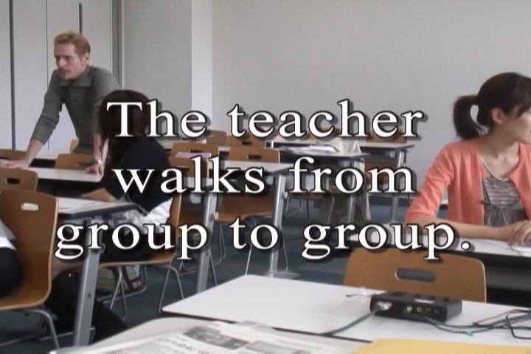 | 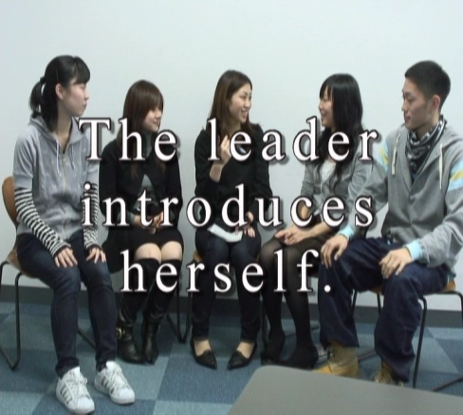 | 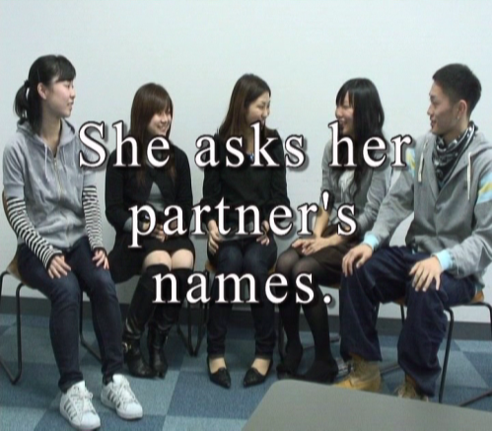

I.(c) INTERRUPTING, CLARIFYING
Numerous classroom activities can be undertaken. An example of one of them is a game to practice interrupting and asking for clarification:

1. The teacher or a student volunteer starts talking on any subject.

2. Anyone in the class can interrupt and disagree with the speaker or ask for clarification if they use the right
expressions.

3. The speaker quickly answers the person who interrupted or provides clarification and resumes talking about the
subject.

4. Everyone else keeps trying to interrupt or ask for clarification as often as possible and in as many ways as
possible to sidetrack the speaker.

I.(d) GIVING A REASON
Another is to practice adding reasons:

1. Get a small group of students to write down the names of different jobs on pieces of paper and then fold over their
papers so they remain unseen.

2. A group member draws a paper and reads it as if it were about the student sitting on the right: "I think you would
be a great singer because..."

3. The first group member passes the paper to the left and that person adds a different reason: "Furthermore..."

4. Humorous or arbitrary reasons are acceptable, too.

5. When the paper has gone around, a new group member draws a second paper.

ASKING OPINIONS | AGREEING | DISAGREEING
What do you think?  What’s your opinion?  What’s your idea?  What do you have to say?  How do you feel about it?  Could you tell me...?  I’d like to ask...  I’d like to know...  I’m interested in... | I agree.  I have the same opinion.  I feel the same way.  Yes, this is what I think.  Likewise for me.  Certainly, that’s true.  Me too.  Likewise. | I disagree.  I can’t believe that.  I have a different opinion.  I have another idea.  I feel differently.  I don’t think so.  I can’t agree.

Figure 1# Turn-taking Language A

Once in groups, students brainstorm topics and determine the order in which each group member will serve as a discussion leader. The discussion leader is responsible for making some points about the subject of the discussion, asking other group members questions, and promoting discussion.
INTERRUPTING | CLARIFICATION | GIVING REASONS
Excuse me for interrupting, but...  May I say something?  Pardon me.  Sorry, but...  Wait a minute!  I might add here...  I’d like to say something… | Would you mind repeating that?  I didn’t catch the last part.  Sorry, I don’t follow you.  What was that?  I didn’t get that. | The main reason is...  Because...  Seeing as how...  This is the reason why...  That’s why...  Furthermore...  And another thing...

Figure 2# Turn-taking Language B

I.(e) ROUND ROBIN
In this exercise, a topic goes around the circle or small group and students either agree or disagree and offer a reason. Their reasons can be outrageous ones.

1. The world is really flat.
2. Santa Claus is a real person.
3. In fact, there is a rabbit making mochi on the moon.
4. The number four is unlucky.
5. All married men should try staying at home as homemakers in order to better appreciate their wives.
6. Your entire life has been a dream.

I.(f) THE SMALL GROUP DISCUSSION TASK
Introduce the weekly task of the small group discussion task in the first class of the semester. Begin with (1) an explanation of the task parts, (2) showing your students the DVD samples of student discussions, (3) rating and discussing the samples with students, (4) doing a sample newspaper discussion in class.

Parts of the Discussion Task
Here are the steps to follow in the first OE I & OE II class:

1. Show the students printouts of articles from online news sources like CNN (http://cnn.com) and the BBC
(http://bbc.co.uk), or from printed newspapers and magazines which they can find in the library, ie. The Japan
Times.

Show them these newspapers online through using a connection in your room. Show them other potential online
news sources as well:
<http://www.asahi-net.or.jp/~gj7h-andr/index.files/news_english_online2.htm>
<http://www.cl.aoyama.ac.jp/~dias/EsllinksNewspapers.html>

If a student in your class has been abroad or is interested in visiting a particular city, then capitalize on that
interest and suggest that they find a newspaper from that place. In the example of a newspaper summary in
Appendix 2, a student, Tomomi Tsunoyama picked a newspaper from the Gold Coast of Australia because she
had lived there.

2. In the first OE I or OE II class, demonstrate how the newspaper article summary is supposed to be done. Give
the students photocopies or print-outs of the article.

3. Have them note the source of publication information as completely as possible (writer, title
of the article, name of the newspaper or magazine, and date) according to APA Style:
e.g., Park, A. (2009). The quest resumes. Time, 30.

or an online newspaper article in which they must note the url, too:
e.g., Barrowclough, A. (12 april 2009). Man survives 180 foot plunge over niagara falls. Time.
Retrieved April 6, 2016, from
http://www.timesonline.co.uk/tol/news/world/ us_and_americas/article5892498.ece

Remind them that they must capitalize the first letter of all the nouns and verbs in the title.
Also, if the url of the article is too long, that they break it into parts before and after the slash
mark /. Have your students check their work with each other. Most of the students will likely
make errors in their notation. For an added incentive, make the activity into a game by
showing the students on the OHC or having them write it on the board.

4. Next, in point form, have them note the following key information:
Who? What? Where? When? Why? How?

Again, this can be compared in groups, or you could check by asking for answers from the class as a whole.

5. Have each students prepare a 10-line summary of the article by answering the W/H questions. Have your
students compare these in groups. Ask them to choose the best one and compare the best summaries on the
OHC. In this manner, you are teaching the students your criteria for assessing their efforts.

6. Have each group choose 5 vocabulary words that are important in the story, then write down a definition of
each of them and a sample sentence. Change your groups, so that each student moves to a new group to other
students the five vocabulary words.

7. Each student writes down an individual opinion (“I thought that...” or “I felt that...”).

8. Finally, each student should prepare three questions for the discussion. In groups, students should share their
opinions and ask their questions. Students should follow the same procedures in preparing for their weekly
discussions.

From the 2nd week, you should have your students practice turn-taking phrases in groups of three and four. When the class starts, you should have your students form into their groups and discuss their topics. Afterward, the discussion leader of each group briefly summarizes the topic and the opinions of his/her group for the class, taking about 5 minutes.

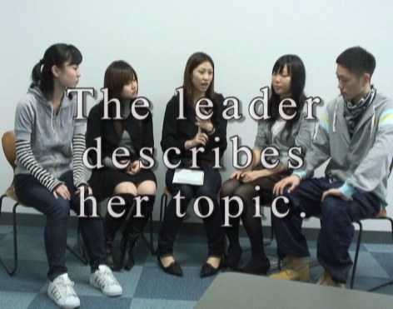 | 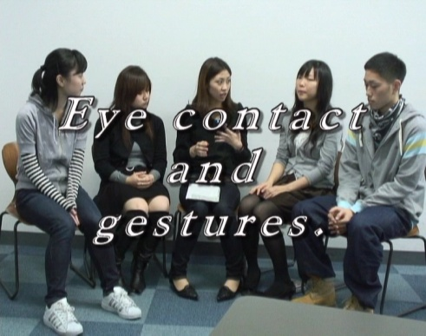 | 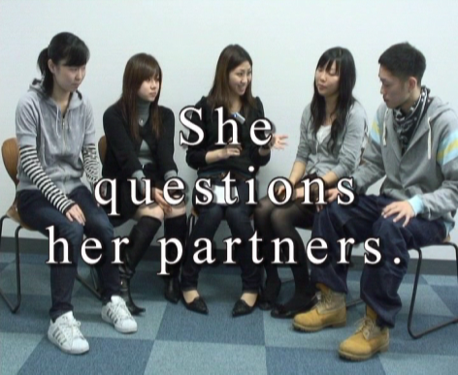

The instructor should comment on the groups’ discussions by pointing out whether they dealt with debatable topics, focused on only one point, involved a significant issue, etc. Each student can also evaluate other students or his/her own performance using the checklist found in Appendix 4. The teacher can collect the checklists, comment on them, and return them to students in the next class.

Useful Expressions for Students to use to Talk about an Article and to Teach Vocabulary
The topic of my news story is…
My news story is about…
Do you know the word…?
Have you ever read/heard of the word…?
Do you know what ________________ means?
Are you familiar with the word…?
The first/second/third/fourth/fifth word in my vocabulary list is…
_________________ is a noun. It is a person who _________________.
_________________ is a verb which means _________________.
The adjective, _________________ that describes _________________.
_________________ is like/ similar to good and it means _________________.

Figure 3# Useful Expressions

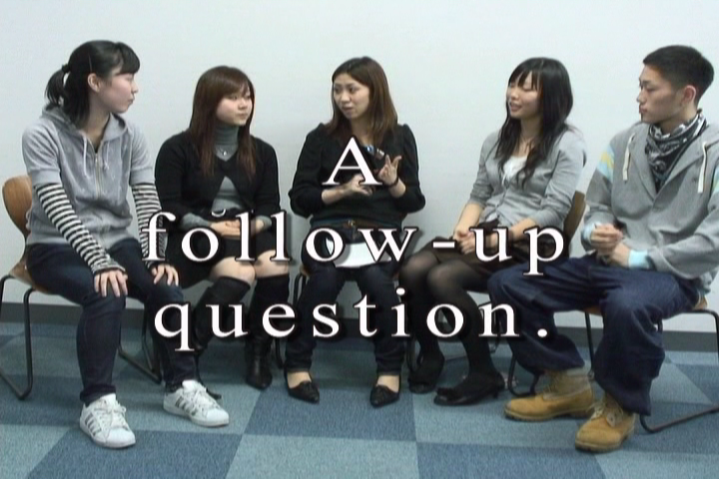

Teaching discussion skills such as the use of follow-up questions should be an ongoing activity in class. Each week, you should focus on a different aspect of it. The following table shows different game-like activities that emphasize effective discussion behaviours such as eye contact, participation, and the use of gestures. It also includes extensions to the task to increase its complexity once students become accustomed to participating in small group discussions.
Discussion Teaching Activities
1. As a class, students form a circle and play “wink  murder.”  2. Students learn how to use gestures by saying a word  and doing the appropriate gesture.  3. Using a check sheet, students count how many times  they use a particular speech act.  4. While engaged in small group discussion, students  are rewarded with a counter or poker chip each time  they take a turn. The winner has the most chips at the  end.  5. To sensitize themselves to eye contact, students  participating in a discussion draw slips of paper  that identify them as high or low eye contact.  Afterward, students guess who drew which slip.  6. In a similar type of activity, students find themselves  designated as a high or low user of gestures, or a  non-user. Other students watching them count the  number of times that the discussion leader or  participants make eye contact, use gestures, or  follow-up questions. | 7. Another activity might be for students to prepare  record the discussion and then transcribe it at home.  By reading and making comments, students will  focus on the grammatical forms.  8. As they improve their abilities in subsequent classes,  ask students in the discussion groups to take turns  shadowing the discussion leader. The leader speaks  for a few minutes, then a student has to paraphrase  what he or she just said.  8. Another useful variation is to have the discussion  group leader paraphrase his or her partners’  responses to the questions. After the discussion, the  leader summarizes these in front of the class.

Figure 4# Discussion Teaching Activities

I.(g) ONLINE RESOURCES
The following websites offer news that can be read online, but also have a multi-media component so that students can hear the same news article read to them, and in some cases, watch a video as well, making the task an even richer one. And there are many online versions of well known newspapers, accessible through Online Newspapers Dot Com at http://www.onlinenewspapers.com.

(1) BBC Learning English
This site includes news articles, audio files, and a vocabulary list. You can hear the story being read and watch video content, too. The website has other useful features for learners such as crossword puzzles, exam skills, games and quizzes, grammar tips, and an online community of language learners http://www.bbc.co.uk/worldservice/learningenglish/newsenglish/

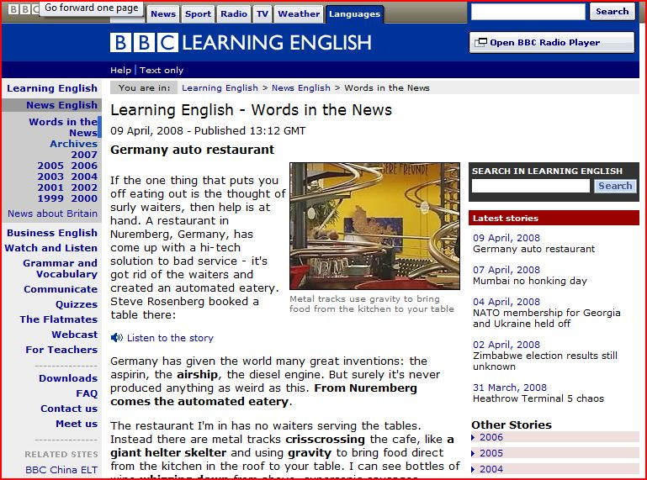
Figure 5# Screenshot of BBC Learning English

Figure 6# Another screenshot of BBC Learning English

(2) Literacy Works
A very special project by Literacyworks, the Western/Pacific Literacy Network and CNN (http://literacynet.org/cnnsf/instructor.html)offers both a newspaper article, and audio and video feeds. The website also includes an instructor page, and an outline of the article, and in some cases, cloze exercises, too. Most of the articles date from 2005 and there are a limited number of them, so a teacher assigning the website for class newspapers would have to track which articles had been used in class.


Figure 7# Screenshot of an article from Literacy Works

(3) NHK
NHK offers a section on their website which provides the text of a short video (http://www.nhk.or.jp/daily/english/10_14.html). In this case, students could watch the video, read the script, copy (http://www.nhk.or.jp/daily/english/10_14.html). In this case, students could watch the video, read the script, copy the script, and hand this in with their newspaper discussion materials. The news is up to date, and on video, making it very high interest, and yet the site still offers a written text.

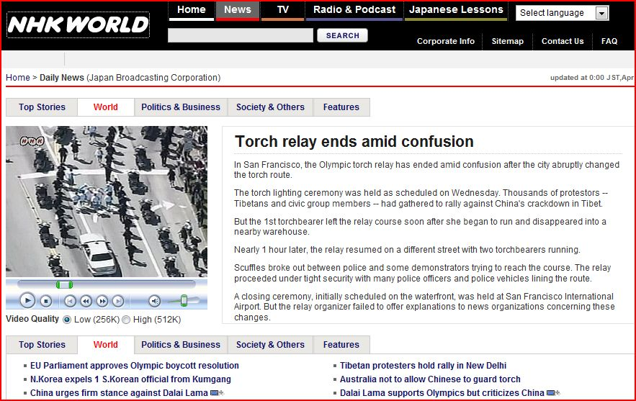

Figure 8# Screenshot of NHK, English World website

(4) The New York Times
This online version of the newspaper offers current news but also includes links for the back story and in some cases, transcripts of podcasts. As with other websites sites, the web version of the newspaper story has been simplified: http://www.nytimes.com/pages/todayspaper/index.html.

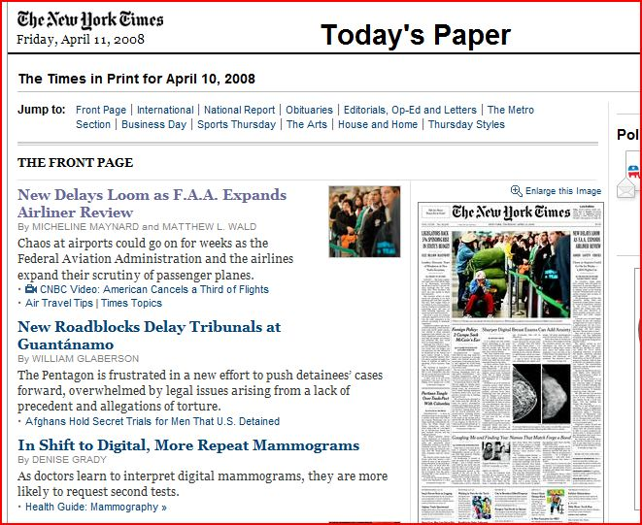

Figure 9# Screenshot of The New York Times website

(5) The Voice of America: Special English

The Voice of America provides simplified news articles on such varied subjects as agriculture, lifestyle, science, and famous Americans and spoken versions of those same articles. The website (http://www.voanews.com/specialenglish/archive/index.cfm?month=3/1/2008) has a Special English section which offers audio files and the transcripts as well. However, there are fewer articles available than on other sites and the news is not breaking news.

Special English Archive
Use the calendar below to find a Special English script from 2001 - present.
The scripts are organized by year, month, and week.
Click on a number to find all scripts broadcast in that week.

2008
Jan |  |  |  | Feb |  |  |  | Mar |  |  |  | Apr |  |  |  | May |  |  |  | Jun |  |  |  | Jul |  |  |  | Aug |  |  |  | Sep |  |  |  | Oct |  |  |  | Nov |  |  |  | Dec
1 | 2 | 3 | 4 | 1 | 2 | 3 | 4 | 1 | 2

Figure 10# Section of an article from VOA, Special English

The website also includes topics such as American Life, Health and Science, Entertainment, Leisure, Science and Technology, as well as regional news from the Americas, Africa, Europe, and Asia. You will need to direct students to particular programs. The site also offers the opportunity for students to choose articles based on different themes.

I.(h) DISCUSSION SHEET SIGN-UP
It is very important to schedule the discussions well in advance. This can be done by circulating a sign-up sheet among the students in your class. However, you must limit the number of people who are allowed to sign up for a particular date. Otherwise, none of the students will want to sign up for the first discussion.

A good sign-up sheet can be produced using Excel as in the example that follows, Figure 11#.

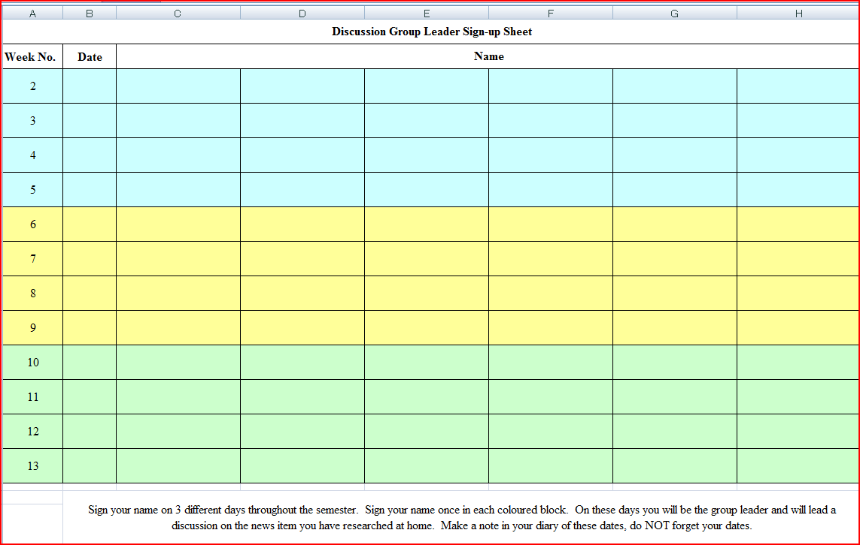

Figure 11# Discussion Leader Sign-up

APPENDIX 2
Tomomi Tsunoyama OE II level

NEWSPAPER SUMMARY
Passengers the Real Heroes: Bus Driver

AJuly 14th, 2008
62-year-old bus driver attacked by two youths on Thursday says his bus passengers were the heroes.
David Newton wrote a letter to The Bulletin yesterday, reassuring family and friends he was OK after being punched in the head outside Australia Fair about 1.20pm.
"A passenger advised me that youths were spraying graffiti on the bus using spray cans and special marker pens," he said. "I caught them in the act and advised them that I was calling the police.
"These youths then tried to escape from the bus without success, as I was assisted by a passenger. They then turned violent on me.
"But after I defended myself and with the assistance of another Surfside driver, they gave up."
Mr Newton said three youths then escaped through the rear skylight hatch of the bus.
"Many people have contacted my family, work and talk back radio about the incident, and I wish to advise them all that I only received minor injuries in the incident," he said.
"I wish to thank a New Zealand tourist, Jim McDougall,
who assisted me in preventing the youths from escaping as well as the prompt action of the police.
"My special hero is a lady named Amber who not only rang the police on her mobile phone, she also took photos of the incident and was able to give the police very good descriptions of the offenders.
"I have since contacted her and she and my wife are going out for a celebration drink for a successful outcome in catching these offenders.
"The good news is that a mobile telephone was found in the skylight.
"On investigation, the police were able to track the owner.
"The phone supplied plenty of photos of other graffiti incidents that the youths have performed.
"A lot of people have asked me whether this incident would put me off bus driving.
"My answer is no, because I am not going to let an incident like this upset me. More than 99.9 per cent of our passengers are a pleasure to deal with."
Three of the youths involved in Thursday's incident are helping police with their investigations. Police are still looking for two of the teenagers.

[Errors of grammar and word choice have not been corrected.]
14 July 2008
Source of the Article:
(2008). Passengers the real heroes: Bus driver. (14 July 2008). The Gold Coast Bulletin. Retrieved March 6, 2016, from http://www.goldcoast.com.au/article/2008/07/14/13642_gold-coast-news.html
Who? ----- David Newton
What? ----- was punched
When? ---- Monday 14 July 2008
Where? ----Australia Fair, Southport
Why? ----- Telling off youths making graffiti in the bus
How? ----- A passenger told him that there were youths vandalizing the bus

Vocabulary
Attacked –trying to harm someone or something
Graffiti – paint or writing on something that spoils its appearance
Advised - gave someone some advice or information
Violent - injurious or destructive force
Hatch - an opening that serves as a doorway or window in the floor or roof of a building.
Summary:
A 62 year old bus driver named David Newton was attacked after telling off youths about spray painting graffiti on the bus. While getting off the bus, a passenger informed Newton that there were youths in the back of the bus, spray cans and special marker pens, spraying graffiti. Newton caught the youths in the act and advised them that he was going to call the police. The three youths tried to escape from the bus, but another passenger stopped their escape, and the youths became violent. Then some of the youths escaped through the rear skylight hatch of the bus.

My opinion:
Graffiti is a big problem within Japan right now as it was discovered that a group of university students have “tagged” one of the world heritage buildings in Italy. Later it was also discovered that a baseball coach of a famous high school had also vandalized a world heritage place. I don’t understand why people would vandalize such famous buildings. It is disrespectful to the people who built such monument. Another recent case of vandalism in Japan is the case where a bullet train was vandalized and had the word ‘Hack’ spray painted on. It is believed that the artist sneaked in from the gap in the fence and had around 20-30 mins to graffiti. These people should be made to clean the graffiti, as a punishment, as well

Questions:
- How do you feel about the rise in vandalism?
- What do you think would be a fair punishment for the people who vandalized?
- Why do you think young people vandalize objects?

II.(b) NEWSPAPER MINDMAPS
You may need to introduce students to the practice of mindmapping to assist them with writing their newspaper summaries. The activity begins with the use of short newspaper articles. Then ask students in small groups to read an article quickly. Everyone in a group has the same article. Tell them to skim the article for general ideas, and mention that they will find out what they don’t know afterward by asking questions of the other members of their group. After a short period of time, ask the students to turn over their papers and tell each other what they can remember.

In their groups, students write down the key words and phrases about the article that came out in their discussion. Then they transfer the information to a “mindmap” of the article, placing the topic in the centre and connecting the main ideas.

The main ideas should have supporting details by them. After each group has finished a mindmap, the group members copy it, and the teacher collects it. Then each group member joins a new group to explain the mindmap and the article. Alternately, students in pairs could explain their articles.

Explanations should be of sufficient detail, so that their partners can accurately give an oral summary of what they have heard. Then the students can offer some opinions about the articles. Time permitting, students who have heard about the articles but have not read them, can be allowed to read them to confirm how much they understood. You might also have them create role plays based on events from their articles and invent what they believe will happen next. Students can write a summary of the news article, too.

APPENDIX 3
TEACHING VOCABULARY
It is important to find out how many words that your students know. At minimum, they need a foundation, a solid working knowledge of the first 200 word families. There are numerous websites offering the Academic Word List for English and several of them also have exercises. These include the word list developed by the language education program of the University of Nottingham. (http://www.nottingham.ac.uk/%7Ealzsh3/acvocab/teaching.htm).

III.(a) 5 PRINCIPLES TO TEACH VOCABULARY
According to researcher William Graebe, there are five general principles for teaching new vocabulary words to students. It is important to teach them how to use these principles themselves. Also, when using these principles in class, identify them to students.

(1) Frequency of Use
Learners need to spend time both directly reviewing the words and also using them in creating sentences, and in spoken use with others.

(2) Repetition
Learners need to see the new vocabulary in a variety of contexts. The repetitions need to be spaced over time.

(3) Spaced Retrieval
Many repetitions of a word are necessary when students first encounter it. Otherwise, they will not remember it. One of the easiest ways and most time-efficient ways of doing this is making flashcards, or getting students to make flashcards as part of their preparation for a newspaper article discussion. You might collect the cards that they make and keep all the student cards together and then review them briefly at the beginning of class.

(4) Avoid Interference
If two words are similar in sound or appearance with each other, avoid teaching them at the same time. Counsel students to avoid trying to learn words from alphabetical lists. Only teach one word of a word family; teach migrate, do not teach immigrate, and emigrate at the same time.

(5) The Generative Principle
Transfer vocabulary words across several different tasks. Have students use words that they have read in writing their journals, their book reports, or in an IE Writing assignment. Try to use these words in directions to your students so that they hear the words from you. The more generatively a vocabulary item is used (ie. noticing it, receptive retrieval, productive retrieval, receptive generative use, productive generative use), the better chance of learning it.

III.(b) VOCABULARY FROM DISCUSSIONS
Introducing vocabulary is an important part of the small group discussion task. One approach to using it with the newspaper discussion is to have each student leader make his or her own flashcard set and a vocabulary quiz for the articles that they present to their discussion groups. Students decide which words they think are the most important ones that their classmates should remember, for example, five to seven words per article. They then prepare flashcards (of a standard size and appearance so that you can keep them and show them in subsequent classes). Afterward, the discussion leader prepares an oral or written quiz based on multiple choice, synonym, antonym, or matching and has their group do it. It is very important to emphasize to students that their vocabulary words should be common, more frequently used ones than long and obscure ones. You might even suggest that they look for the words on the academic word list mentioned earlier.
The second technique, sometimes called “word web” or “vocabulary brainstorming,” is a whole-group activity led by the teacher and noted on the OHC or chalkboard. The teacher elicits words from the students and draws a mind map of related terms, which may or may not have appeared in the article. For example, the word “election” can be associated with “elect, vote, voter, candidate, dark horse, front runner, ballot, political party” and other terms. These words can be used to make original sentences or stimulate further conversation on the topic. The teacher can record them and periodically question students about them.

One vocabulary game to review vocabulary words in class is the “stand-up-sit down” one. The teacher calls on a student and asks them to think of sentence using the word. If the student gets the sentence right, they can sit down and rest. Otherwise, they must remain standing.

A second vocabulary game is to divide students into teams. Each team makes a list of six or more words from the vocabulary being studied in the class. Each team challenges another team to define the words and use them in a grammatically correct sentence. The team that gets the most right progresses through the competition until there is a final winner. By one teacher’s account, students in his class stayed up late studying so that could win!

Useful Expressions For Teaching Vocabulary

Do you know the word _____?  Do you know what _____ means?  Have you ever heard of the word _____?  Are you familiar with the word_____?  The first word in my vocabulary list is _____.  The second / next third / fourth / last  _____ is a noun.  It is a person who _____.  --thing which  --place where | _____ is a verb that means to _____.  _____ is an adjective/ adverb  that describes _____.  It's how you feel when _____.  _____ is like _____(, but it means _____.)  --similar to  --a synonym of  _____ is the opposite of _____.  --an antonym  For example, _____.
Students should also maintain lists of words in a vocabulary notebook that they keep for the class. These words could be assessed through a vocabulary test at the end of the term, or by the teacher taking in the books and assessing them as a type of portfolio assignment.

Figure 12# Useful Expressions for Teaching Vocabulary

III.(c) VOCABULARY NOTEBOOKS
Figure 13# shows the type of information that would be included in a vocabulary notebook. This form was made using an Excel spreadsheet. This type of student assignment should be assessed frequently. When it is first introduced to the class, you should show past examples of student notebooks to explain what you expect. After the first week, it would be a very good idea to collect all the notebooks and to grade them and later to display some of the better ones.

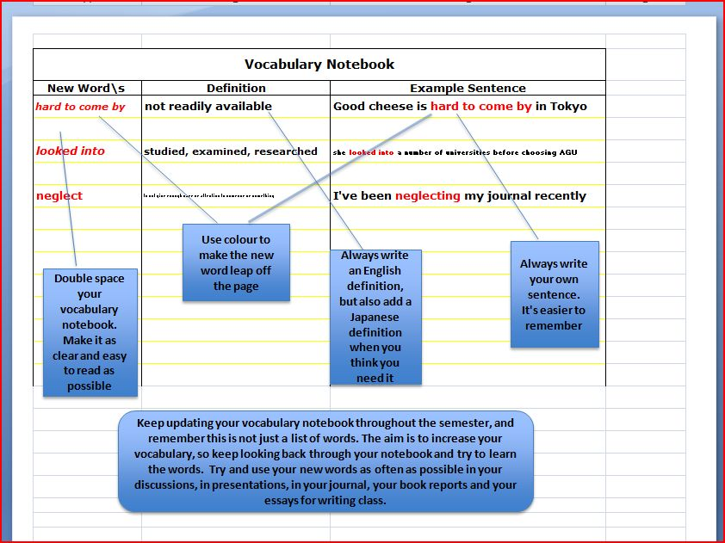

Figure 13# Sample Vocabulary Notebook

III.(d) VOCABULARY LISTS
You should emphasize to students that learning vocabulary items will be learned more effectively the more often they are used. The vocabulary will be reinforced when students encounter them in readings and when listening to films, and news.
Student Self-assessment
Students can quickly check your vocabulary level at a University of Montreal website http://www.er.uqam.ca/nobel/r21270/levels/ or at a commercial website run by Lexxica at http://www.wordengine.jp/vcheck

III.(e) VOCABULARY ACTIVITIES

14 VOCABULARY BUILDING ACTIVITIES
1. Brainstorming and Mapping
Assist students in listing related words.

2. Classification
Students classify words into logical categories (air pollution, water pollution, etc.), or structural categories
(nouns, verbs, adjectives)

3. Comparison
Prepare a list of synonyms that students know and ask them to find corresponding words in
the text that carry the same meaning. Alternately, the students could look for contrasting
words and meanings.

4. Context
Get the students to look for context clues that use description, explanation, contrast, or cause-effect to explain the
meaning of certain words.

5. Definition
Underline the words you think students should know and they look them up in a dictionary.

6. Feeling
Get the students to infer the meanings of the words from the mood of the reading, write own
their definitions of the words and share them with their peers.

7. Matching
Give students a list of words and their definitions in a random order and they match them up.

8. Modified Cloze
Students find the missing words in a section of the text where you have cloze key
vocabulary.

9. Realia
Use the actual object or a board diagram to explain a word.

10. Synonym
Look for synonyms the writer uses to convey the same meaning.

11. Roots and Affixes
Students identify root words and their affixes (prefix or suffix) in the text. Discuss their
meanings (educate; education; educable).

12. Modified Cloze
Students find the missing words in a section of the text where you have deleted key
technical or conceptual words.

13. Vocabulary Mime
Choose different vocabulary words from the text and put them into a box. Have students
(or one student from each group) come to the front of the class to pick one up and mime
them for the rest of class or their group.

14. Retelling
Summarize a passage using key vocabulary.

15. Roots and Affixes
Students identify root words and their affixes (prefix or suffix) in the text. Discuss their
meanings (educate; education, educable).

16. Skimming and Peer Tutorial
Students skim the passage to find unfamiliar words, then ask another student for their help.

Figure 14# Classroom Vocabulary Activities

This list can be used to re-introduce vocabulary items from a classroom textbook that you may be using. The point is that teachers should consciously deal with vocabulary in their classes.
APPENDIX 4
ASSESSING DISCUSSIONS
Early in the class, you should show students the sample DVD and ask them to rate the discussion groups. First, show the explanation of the discussion leader’s task, then depending on whether or not the class is OE 1 or OE 2, show the part of the DVD that needs to be rated (IE 2 and 3 correspond with OE 2). The students should then check each group on the following scale. This scale classifies the discussion leader’s efforts in terms of an explanation, questioning, and non-verbal communication. After the students have made their choices, please let them know your score for the groups.

 | Explaining | Questioning | Non-verbally Communicating
3 | a) Described the main points  of the article without  reading  b) Explained vocabulary when  needed, using only English  c) Paraphrased partners’  comments accurately | 1) Asked partners questions,  used their names, and  encouraged their  participation.  b) Used follow-up questions  and rephrased them as  necessary.  c) Employed questioning to  direct the discussion and to  clarify points. | a) Frequent, natural eye contact.  b) Appropriate, helpful gestures.  c) Good posture and sensitivity  to the body language of other  group members.
2 | Any combination of 2 descriptors from a, b, c. | Any combination of 2 descriptors from a, b, c. | Any combination of 2 descriptors from a, b, c.
1 | 1 descriptor from a, b, or c. | 1 descriptor from a, b, or c. | 1 descriptor from a, b, or c.
0 | Read the article aloud. | Read the questions aloud. | No eye contact or gestures.

Figure 15# Assessment Scale for OE Discussion Leaders

IV.(b) STUDENT SELF-EVALUATIONS
A simple form for students to evaluate their own discussion performance is included below. It contains the same three headings as the Assessment scale but the form is a simple checklist. Its purpose is as a reminder to the discussion leaders of what they should do during a discussion.

Self-evaluation should be a regular feature of the small group discussion task.

Discussion Checklist:
A. Explaining
- describes the content thoroughly (without excessive reading from notes)
- summarizes partners’ comments after each question

B. Questioning
- asks partners a variety of questions
d) uses follow-up questions when necessary

C. Communicating Non-verbally
- makes frequent eye contact with partners
- uses gestures frequently (e.g., pointing to a photograph or headline)

Explaining |  | Questioning |  | Communicating Non-verbally
a) describing |  | c) asking questions |  | e) making eye contact
b) summarizing |  | d) using follow-up  questions |  | f) using gestures

Figure 16# Checklist

APPENDIX 5

OE 1: POSTERS AND PSA/CMs

In the Fall term of OE 1, you will have a choice of three different tasks to do with your students. The first, an interview with a native speaker of English, will lead to developing a poster about that interview. The second project asks students to create a poster on a theme related to their newspaper discussions or to readings that have been done in class. The third possible task for your students is for them to work on creating a PSA (Public Service Announcement) or a Commercial.

V.(a) POSTERS
Posters are an excellent way to create a speaking activity. The teacher provides students with a theme based on the readings or discussions in class. Each student, or each pair of students, prepares an attractive and well-designed poster on A-3 size paper. The following student posters are on the themes of biography and famous people and geography, taken from New Interchange 2. “Ingredients of Good Posters” show a list of the criteria for making an effective poster.

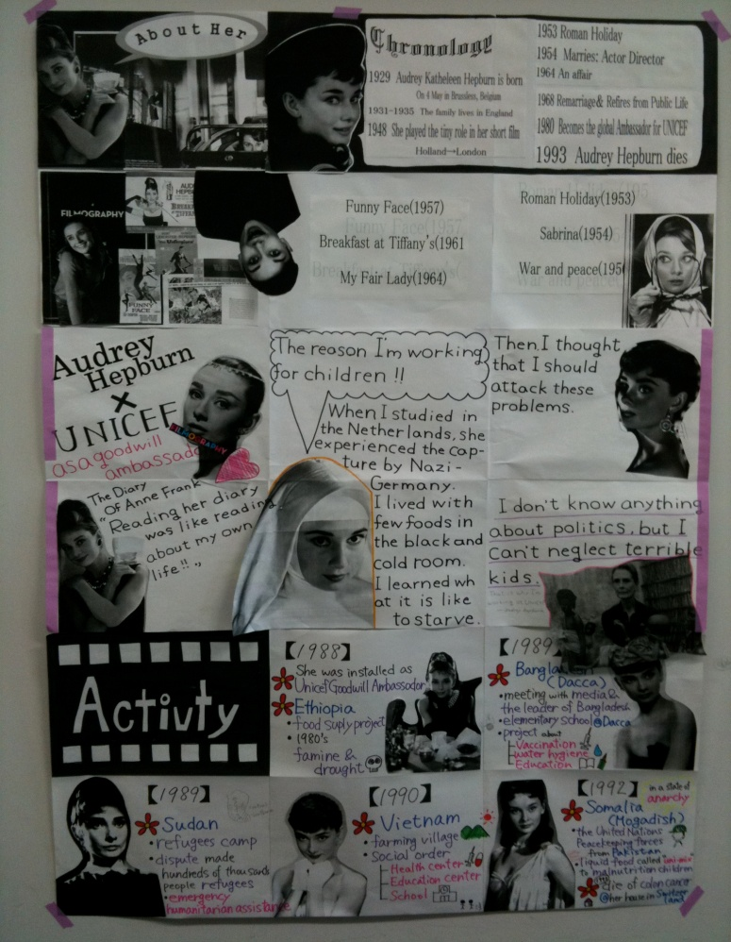 | Ingredients of Good Posters
● Attractive visuals
(charts, diagrams, drawings, maps,
photographs, or graphs)

● Use of lettering
(font, text size)

● Written text
(choice of words)

● Use of colour

● Information

Figure 17# Poster for Biography: Audrey Hepburn
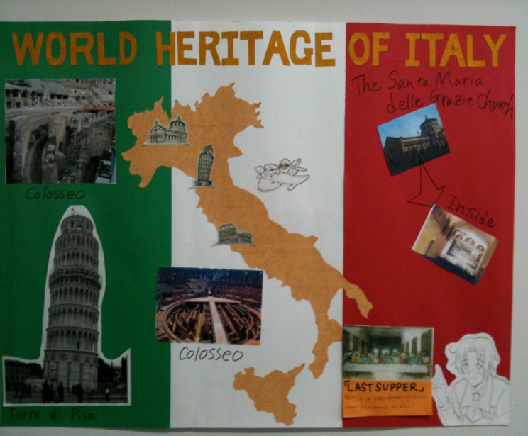 | 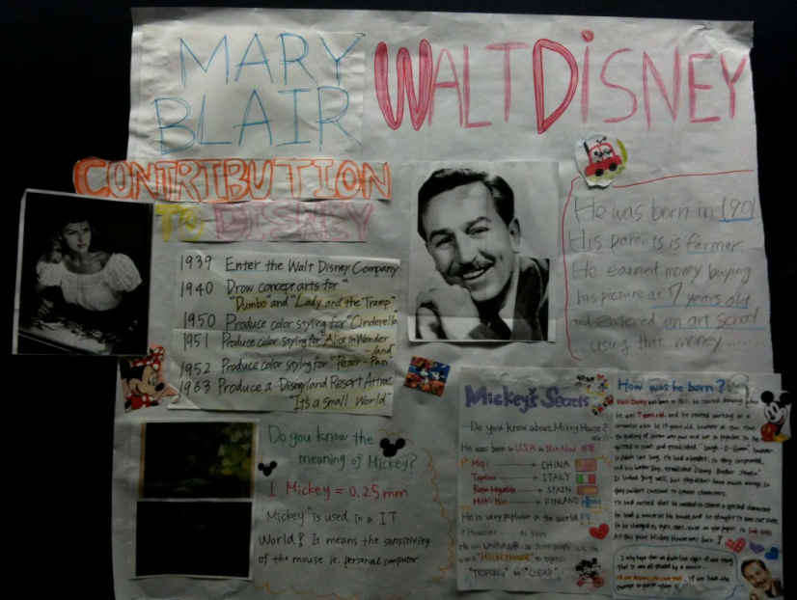
Figure 18# Poster for Geography and Biography: Italy and Walt Disney

V.(b) THE POSTER CAROUSEL
When the assignment is due, the posters go on display in a “poster carousel.” Half the class hangs their posters on the walls with masking tape, (a special tape that won’t damage paint!) and stands by the posters answering questions. The rest of the class views the posters and asks questions. Then you switch the two groups of students. While students are viewing the posters, you might ask them to choose their favourite three posters, and their favourite three explanations of poster. This can be taken up with the class. These student comments can also aid you in rating the posters.

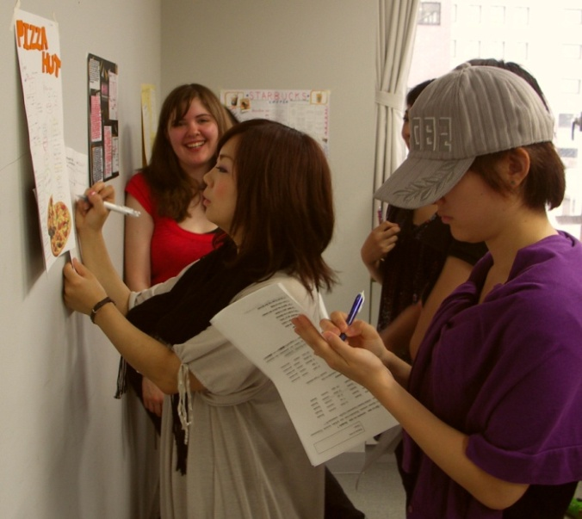 | 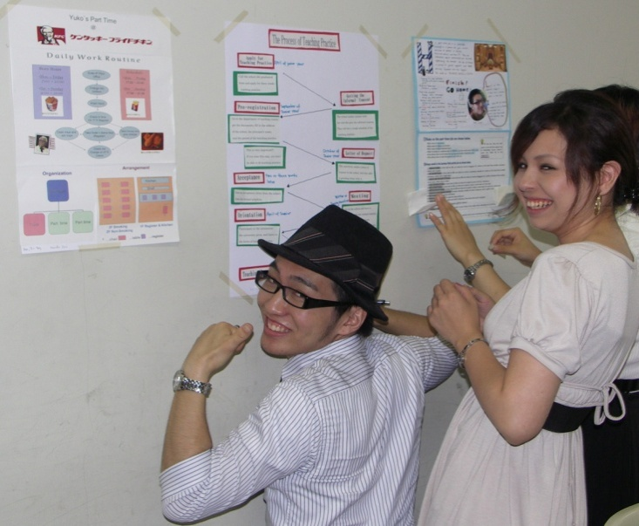

V.(b) PSAs AND COMMERCIALS
Making a PSA or commercial can be a highly motivating task. However, it will need a great deal of teacher preparation and scaffolding to make sure that students do a good job. Only older commercials are available on video or DVDs in our teacher resource library in the English Department. More recent ones can be viewed on YouTube. In addition, the Teacher Resource Center. 9F, Goucher Building has DVDS of commercials from around the world. Viewing these may help get your students get started.

Among the aspects of this task are that students should learn the use of persuasive language and other forms of rhetoric such as appeals to logic, to a medical or scientific authority. The most common technique in a commercial is that of an emotional appeal, for example, a commercial of a new car streaking down an open road, the narrator’s voice declaiming its ease, freedom, and power. These could be taught in class and students in groups could improvise short sketches using persuasive language and based on objects that the teacher has brought to class. Perhaps a bag of objects (therefore hidden from view) could be circulated among the groups. Then a person from each group could select the object, for example, a hair brush, or a watch. Students in groups could then create commercials around these objects. Using an “applause-o-meter” (the amount of applause from the group), the class chooses the group with the funniest commercial.

THE LANGUAGE OF ADVERTISING
Advertising may be of two different types: that which is more informative and often found in PSAs; or commercial advertising which relies on emotional appeals. Any number of the following advertising appeals may be used in a single advertisement. (Have students create their own advertisements in the blank spaces.)

- Exagerated claims - These are the most common of advertising strategies. Exaggerated
claims are made for the use of the product.

ie. "This wonderful new breakfast drink will make a difference
to your day."

2. Unfinished comparisons - Unfinished comparisons are made when an advertiser appears to be making a comparison but does not make one.

ie. "Ford LTD---700% quieter."
ie.

3. Weasels or Modifiers - These occur whenever an advertiser modifies a claim.

ie. "Crest toothpaste helps prevent decay."
ie.

4. Preemptive claims - Because they use patented brand names, advertisers can claim their product is unique.

ie. "If the tire doesn't say Goodyear, it can't be polyglas."
ie.

5. "So What?" Claims - In contrast to preemptive claims are claims that are true of all products of a certain type.

ie. "Mobile: the detergent gasoline." (all gasolines are detergents)
ie.

6. Scientific Claims - By using scientific names, the advertisers suggest that the product has been developed
by scientists in laboratory conditions.
ie. "Wonder Bread helps build bodies 12 ways."
ie. "Swedish formula hair replacement."
ie.

7. Vague claims - These are claims that often use metaphors, or other poetic devices to create an emotional appeal.

ie. "A Saab 900 Turbo drives like nothing on earth."
ie. "No one ever promised you a rose garden so you grew your own---American Express
ie.

8. Flattery - Any claims that users of a certain product are better people than
others is an appeal to flattery.

ie. "For those with discriminating taste---Chivas Regal."
ie.

9. Rhetorical Questions - These occur when the advertiser asks the reader a question.

ie. "Are you tough enough to be in the U.S. Marine Corps?"
ie.

Figure 19# The Language of Advertising

Making commercials can take different forms. It is not necessary that students actually make a film. In fact, there are several worthwhile and less time-consuming alternatives. The first, mentioned previously, is simply to have students act out their commercials in class. The entire process could be done within a single class. A second approach, that of improvising commercials in class could be a step toward writing and photographing one, or recording one. One further point, making a “parody” of a commercial about a ridiculous product such as a spray that make your car smell new, or a vitamin drink that gives people superhuman powers is an easy and highly motivating approach.

Refer to these websites for inspiration:

Adbusters — Spoof Ads.
http://www.adbusters.org/spoofads/

Ad Council — View PSAs (public service announcements)
http://www.adcouncil.org/gallery.html

Ads from an Anti-Drug Media Campaign — Watch dozens of ads (many with transcripts)
http://www.mediacampaign.com/mg/television.html

Digital Scriptorium — See American ads in their historical context (also view by category) http://scriptorium.lib.duke.edu/adaccess/

Advertising Jingles — Hear advertising jingles for dozens of food products
http://www.geocities.com/Athens/Rhodes/4190/jingles.htm

Storyboards
To plan their shoots efficiently, film directors and film crews employ storyboards showing the action, dialogue and setting in a film. Underneath each of the drawings in a storyboard are commentary, dialogue, and production notes. In much the same way, making a commercial in class should be a process with a number of steps rather than simply letting students wander about with a video camera.

Artist Josh Shephard’s website showcases storyboards for different genres of film (http://www.thestoryboardartist.com/Site/Home.html). The Department of Education website at the University of Hawaii offers a complete 28-panel storyboard for an instructional video on parking a car (http://www2.hawaii.edu/~ricky/etec/sboardtemplate.html).

The site also includes a downloadable storyboard with blank lines for noting the visuals, audio, transitions, and tracking time. Showing these materials in class can explain storyboards to students as well as provide a framework in which to build their own. Storyboards can also help students to analyze how the plot, conflict, and camera angles of a film contribute to the story.

STORY BOARD
Speaker | Dialogue | Visuals / Props | Sound Effects

Figure 20# A Storyboard Form

See more examples of storyboards at http://www.sotherden.com/video101/storyboard.htm

The Photo Strip
Another script-based task series is for students to prepare a storyboard for a commercial with photographs and make it into a poster. This would be a time-saving yet fun approach to making a commercial. Most new laptops have built-in cameras, or the cameras are relatively inexpensive to purchase as an add on. Shooting snapshots and altering them with such special effects as distorted images, negatives images, sepia tones, or high contrast shots is easy to do.

Comic Life comes bundled with new Mac Powerbooks™, or as an inexpensive download for other Mac users and for other platforms such as PC (http://plasq.com/downloads/). It also is available for a free 1-month trial which means that you can ask your students to download it onto their home computers, and create a poster. Comic Life allows users to caption photographs with cartoon-style printing, and speech balloons for dialogue and character thoughts.
This is a photo strip created by students who went on a fieldtrip in 2008 to see an amateur theatre production of Bernard Pomerance’s 1979 play, The Elephant Man, a man whose hideous deformities led to his nickname. Students created scenes from the back story to the play, his early life. Figure 21# shows how one student group created a new scene from the Elephant Man’s life.

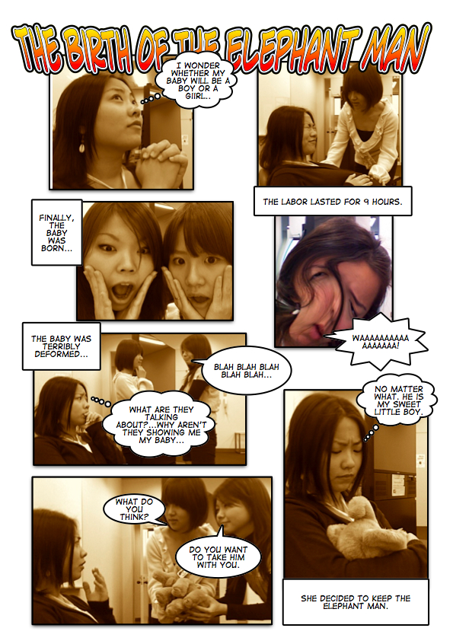

Figure 21# Birth of the Elephant Man
Audio Commercials
Again, teachers need to consider whether or not to record at all, then choose the appropriate medium for it. A very low-tech audio recording of a scene can be done with a minimum of equipment and student training: a tape recorder and a blank cassette. Furthermore, in an audio recording, students can read from their scripts rather than try to memorize their parts. Sound effects can be added to enhance the imagination of both listener and producers. A higher tech solution is using microphones with iPods™, MP3 players, or other portable recording devices and a computer for downloading and mixing sound effects such as those available from the Free Sound Project (http://freesound.iua.upf.edu/searchText.php). Audacity is a program that enables users to record on multi-tracks; a free download from http://en.flossmanuals.net/Audacity.

Filming Commercials
To begin with, you will need to visit the Foreign Foreign Language Lab, 6F, the Goucher Memorial Building (Building 15) and examine our digital cameras, and software. To provide students with an orientation to a camera, camera angles (close-up, medium, and long shots; high and low camera angles, videotaping, and use of a tripod), you might sign out some cameras and then have students in groups practice in class. The Foreign Language Lab will also provide an orientation to the Windows-based editing software available on the computers in our Foreign Language Laboratory. Free online tutorials on filmmaking and editing can be accessed on iMovie Tutorial (http://www.apple.com/support/imovie/tutorial/index.html) and Windows 7(http://www.microsoft.com/windowsxp/using/moviemaker/create/default.mspx).

Students also can edit their films in the Foreign Foreign Language Lab.

Here are the steps in filming a commercial:

1. After showing commercials to your group, brainstorm as many products and services as they can think of within
5 minutes.

2. Following this, groups of students try to develop advertising slogans for a few products, or services.

3. Each group creates a commercial storyboard for homework. [Use the form on page 40.]

- Group members revise these storyboards.

- Rehearsals are conducted before the actual filming.

- Filming should be done outside of class with the use of equipment borrowed from the Media Library (the 3rd
Floor of Building B). If time permits, filming may be done during class time.

The British Columbia Ministry of Education offers teachers the online curriculum guide for a Fine Arts course in film and drama with very useful learning outcomes, resources, suggested projects, and student assessment scales at http://www.bced.gov.bc.ca/irp/film1112/filpref.htm.

Class discussion of the commercials afterward should focus on 1) how each commercial tried to get the audience’s attention with language, visuals, and rhetorical persuasion, 2) how the characters and the product or service appeared in the commercial, and 3) how likely other students might be to purchase the product.
APPENDIX 6
OE 1: STUDENT INTERVIEW PROJECTS
VI.(a) IN-CLASS INTERVIEW PROJECTS
These projects, developed by Deborah Bollinger, provide opportunities for students to develop their listening and speaking abilities, and in addition, in the case of interviewing returnees or guest or native speakers, opportunities to increase their intercultural awareness. The tasks proceed in the following manner.

- Learner Profiles
- Teacher Interview
- Peer Interviews
- Interview Planning Questionnaire
- Student Sign-up Sheet
- Ethnographic Interview Questions
- Role Playing Questions
- Guest Speaker Interview
- Options for Recording Interviews: Skype, audio, and e-mail
- Questions for Reflection

Learner profiles provide information that can be used for peer interviews in class. Each student fills out a form with information about his/her background, interests, experiences learning English, experiences abroad, if any, and two questions to ask the teacher. These last two questions are compiled for a teacher interview. Alternately, students can brainstorm some questions to ask in the teacher interview. These might include such questions as “Where is your hometown? Where do you live now? How long have you lived in Japan? How well do you speak Japanese? What other language(s) can you speak? What subjects did you study at university? Why did you decide to become an English teacher? Which countries have you visited?”

Based on information from the Learner Profiles, the teacher asks several students to share some of their experiences living, studying, and/or doing homestays abroad. Other students in the class prepare questions for peer interviews. Then, in small groups, the students take turns interviewing their peers about the countries that they have visited.

In preparation for doing off-campus interviews, described in Section VI. (b), each student completes an Interview Planning Questionnaire, which includes the name of their interviewee, pertinent details about the time and location of the interview, etc. In addition to helping students organize their project, the questionnaire is useful in terms of trouble shooting potential problems. This is an appropriate time to discuss the safety precautions listed in the interview protocol in Section VI.(b.)

Next, the teacher circulates a student sign-up sheet with each student’s name, his/her partner’s name (if any), the interviewee’s name, date of the interview, and interview format (e.g. in person, skype, email). (To address potential concerns about privacy, students should be asked to create a new email address or Skype address for this project.)

Ethnographic Interview Questions developed from Spradley’s 1979 work, The ethnographic interview (New York: Harcourt Brace Jovanovich College Publishers) are practiced in class. These questions form the basis of students’ interviews conducted off campus and can be used for peer interviews or for guest speaker interviews in class, too. The question types and sample questions could also be adapted by students for peer interviews about part-time jobs or club activities. Alternately, these questions could be adapted.
Students could use them for an oral history project with a family member.

In brief, there are four types of questions for students and to facilitate their finding out more detailed information and explanations during their interviews. Students use these to help them generate additional questions of their own.

- Grand Tour Questions – general questions
- Could you describe a typical day at your job?
- Could you describe a typical day on your holiday?
- Could you describe a typical day in your life?
- Could you draw me a map showing the layout of your home/workplace/neighborhood and tell me
about some interesting places?

- Details through Questions – asking follow-up questions
- Could you tell me what happened on a recent day at work, from the moment you arrived
until the moment you left?
b) Could you tell me what happened on the first day of your trip/homestay/university studies, etc.?
c) Could you describe your work/holiday/school schedule to me?

- Experience Questions
- Could you tell me how you made friends at work/during your trip/during your homestay, etc.?
- Could you describe some places you visited while on your trip/your homestay, etc.?
- Could you describe the transportation system/food/currency/leisure activities?
- Could you describe your favorite/worst/funniest experience?
- Could you describe a challenging situation and how you dealt with it?

- Native-like Questions – asking the interviewee or guest to use his/her own words
- Could you tell me what you called your host parents/teacher?
- Could you tell us some of the special names for things at your job/in the language of the country
you visited/had your homestay?

Role Playing Questions is the next step. Students practise interviewing one another. One student role plays the guest or interviewee and two or three other students practice questioning that student. Then students change roles.

The Guest Speaker Interview begins with careful teacher preparation for the event. Preparations should include contacting the guest by phone and/or email, a preliminary teacher interview of the guest (letting him/her know your students’ level of comprehension and impressing upon the guest the need for visual aids), a visit to the guest’s place of work, and/or accessing relevant websites, posting articles for students to read on the teacher’s website or handing these out in class. There may also be video resources for the visit as well. Then students role play their questioning before the guest’s visit.

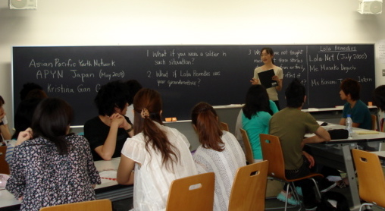 | 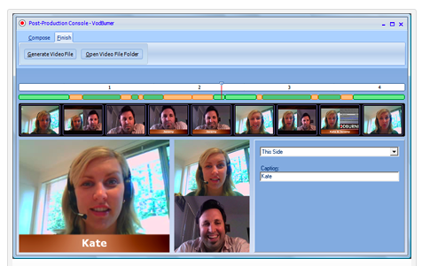
Figure 22#: Guest Speaker using Blackboard and Skype Digital Recording
Skype, audio, and e-mail are all different means of recording interviews. The recording can then be analyzed by students, or form part of a presentation. Language partners for the activity can be found on two different sites. “Skype community” offers a chance for prospective language partners to meet through http://community.skype.com/t5/Language-learning/English-Language-Partner/td-p/330560/page/5. Students can record their interviews by registering for a 14-week trial of Skype recording software such as Hodburner (http://www.vodburner.com/) or IM Capture for MACs which offers a free trial version (http://www.imcapture.com/IMCapture-for-Skype/). Students interviewing one another should use the record function on their cell phones. Another site, dedicated to e-mail users learning different languages through e-mail can be found at http://www.italki.com/whatisitalki. Again, our students should be cautioned to create an e-mail address especially for the project.

Questions for Reflection after the interview project is finished are a good way to engage students in larger questions about their ideas and about language learning. Ideally, students should develop these by themselves. That way, they will have more invested in their answers.

Questions for Reflection:
- Did you agree or disagree with any points made by the interviewee?
- Which experiences could you relate to?
- What did you learn about another culture?
- What insights did you gain about Japanese culture?
- What did you learn from doing the interview?
- If you had to do the interview over again, what other questions might you ask?

VI.(b) LIVE INTERVIEWS OFF-CAMPUS
These interviews offer students the opportunity to use English in public in a real-life situation. However, care should be taken, so that students work in safety. First, students must do any interviews like this working in pairs. Ideally, these interviews could form part of an official class fieldtrip to a museum or to a theatre. Alternately, students could conduct interviews at a public event such as Earth Day in Yoyogi Park, or a fair at an international school (ie. ASIJ, Seisen, Sacred Heart, St. Mary’s, St. Maur’s, etc.).

In addition, the following protocol should be reviewed with students. Again, doing the interviews on a class trip is a safe and supervised way of doing this task.

The interview protocol
This protocol should be reviewed in class and role played so that students know how to handle themselves:
a) Remind students never to accept any invitations to someone’s home
b) Students should never give out personal information such as telephone numbers; only e-mail addresses created for
the assignment
c) Tell women students that it is better for them to approach couples or other females to ask interview questions
d) Student may feel uncomfortable with an interviewee, and should know how to make excuses and to leave

Finally, students present what they have learned to their classmates. This presentation should be assessed according to criteria found in the Appendix 7.

APPENDIX 7

OE 2: GROUP PRESENTATIONS
The ability to make an effective presentation to a group is a very important skill whether students are going on to take graduate school business school courses, and eventually join the corporate world, or simply trying to improve their English by completing tasks in the course, or whether they hope to enter the workforce after high school. The following descriptions explain how you can get students to collect data for their presentations.

VII.(a) SURVEY PROJECTS
This task involves preparing an outline, an introduction, main points, and a conclusion. It also includes developing visuals for use in a presentation, conducting community interviews, collating the findings and generalizing from them. A class developing surveys for the theme of the Environment could have groups working on recycling, use of public transportation, energy consumption, and appreciation of nature.

One working on the theme of the Media could have groups working on TV news, radio, TV drama, movies, and newspapers. A group could ask questions such as "How many hours of TV do you watch each day?" How many TVs have you got?" Who's your favourite news anchor?"

You can prepare students for doing surveys by conducting practice surveys in your class. The kinds of problems students encounter are in formulating appropriate questions and overcoming their shyness about asking questions.

Students should be encouraged to create survey items which elicit a wide variety of response types: 1) those that ask for numbers [i.e., How many newspapers does your family subscribe to? (a)none, (b)one, (c)two, (d)three, (e)four or more], 2) those asking respondents to make a choice from a limited number of possibilities [i.e., “Which type of movie do you prefer? (a)Romance, (b)Adventure, (c)Comedy, (d)Horror, (e)Science Fiction, (f)Other], and 3) ones requiring open-ended responses [Tell about the scariest experience in your life?]. Students should find ways of picturing their data using bar graphs and pie charts, etc. (Excel can be helpful in this regard).

As for dealing with student shyness, practice in formulating questions and asking them in role plays is an excellent way to build student confidence.

Teachers using computer rooms can have students generate their surveys at surveymonkey.com—a service for generating online surveys; the free mode is more than sufficient for the small-scale surveys our students will be creating.

SURVEY PRACTICE
1. Hand out slips of paper to your students. Ask them to write down an answer to 3 questions (a),(b),(c),(d):
(a) Have you been abroad?
(b) How long does it take you to travel to the Sagamihara campus?
(c) How many people do you live with?
(d) Are you the eldest child in your family? The middle? Or the youngest?

2. Collect the papers.

3. Ask for several student volunteers to help you record the answers on the board.

4. Once all the data has been collected, show the students how you could
represent it using different kinds of visuals:

(a) pie graph for the percentages of those who have been abroad, etc.
(b) bar graph for the travel time
(c) line graph for family size
(d) proportional figures for birth order

VII.(b) COMMUNITY SURVEYS
Community surveys where students survey each other, family members, people in the community, or native speakers are an excellent way to teach students about rudimentary ethnographic research and to interest them in the activity. There are many possible topics. These could be brainstormed in class and include such issues as tuition and entrance exams.

The students should meet again after gathering their data so that they can interpret it. You may suggest some methods of categorizing the data, such as by correlating certain responses with sex and age. Afterward, each group makes a presentation to the class, taking questions from the class. Students should be encouraged to use visuals instead of reading from their notes.

Follow-up activities after the presentations could include summary writing. Differences in opinion about the data could even generate topics for a class debate.

VII.(c) EMAIL AND COMMUNITY SURVEYS Several OE teachers do computer survey projects in class. This is an excellent way to encourage students to become more familiar with computers. It is also a good way for them to learn English because they will be making contact with other students through English.

1. Online surveys can be carried out in a variety of ways. One way is to have students join an Internet group (for
example, http://www.yahoogroups.com/) related to their topic and submit survey items in a message to the group.

As most students will not have had experience with electronic groups, such as yahoo groups or google groups,
please familiarize them with the basics of ‘netiquette.’ A much more simple approach is to have students
submit their survey items at a site that is intended for the exchange of surveys by ESL students and those
interested in cross-cultural exchanges. It can be accessed at http://www.iecc.org/survey/. A third method is to
make use of surveymonkey’s free mode at http://www.surveymonkey.com/.

2. For both email or web surveys and community surveys, the next step is the same. Students generate survey
questions, perhaps 10 different questions for each group of four.

3. Class time should be set aside for group meetings and data collation.

4. Additional follow-up activities could include having students write summaries of what they have heard, a kind of
simple comprehension check. Other activities might be a class debate on controversial issues raised by the survey.

VII.(d) RATING PRESENTATIONS
When your students make their presentations, you should require them to prepare detailed notes and create visual aids such as OHCs, handouts, or Powerpoint slides. However, it is very important for them to practice delivering their presentation and avoid reading at all times. This is something that could be scheduled in class time. In general, your students will need prompting and structure to do this well.

A presentation is a performance. Your students need to think of the physical aspects of it as well as the visuals that they will show to the class and how they will present the information.

The 3 parts of a presentation to consider are the Physical Aspects, Visual Aids, and Speech Organization. The physical aspects include nonverbal communication as in an IE Discussion, but also your tone of voice, delivery, and your poster. Visual aids include handouts, OHCs, and Powerpoint slides. Finally, a good speech should be organized in the same way as a paragraph or an essay.

This means that your speech organization should have an (a) introduction, (b) a body (consisting of several points that you wish to make), (c) transitions (to move from one point to another), and (d) a conclusion. An excellent resource, available in the English Dept library is Harrington, D. and LeBeau, C. (2009) Speaking of Speech. (rev. ed.) Macmillan Language House: Tokyo. It includes a DVD of sample student presentations.
Physical Aspects | Visual Aids | Speech Organization
● Avoided reading from  papers or notes as much as  possible  ● Made eye contact with the  audience  ● Used gestures  ● Spoke clearly and with  an attractive tone of voice  ● Spoke loudly enough | ● Used attractive visuals that  might include  photographs,  board notes or sketches,  models, powerpoint slides,  or web sites  ● Explained them carefully  ● Operated a-v equipment  smoothly and effectively | ● Introduction  - Greeting  - Overview of main points  ● Body of the talk  - 1st point  examples  - Transition  - 2nd point  Examples  - Transition  - 3rd point  examples  - Conclusion  - Reminder of the 3 points  - Thanking the audience

Figure 23# Speech Organization

Students need to be taught the importance of transitions in making a presentation. Of course, some of them can be very useful in writing as well.

Introducing | Moving Along | Concluding
- Let me begin with…  - First of all…  - In the first place…  - To start off…  - In the beginning…  - It started with… | - Next…  - Now, I’d like to go to…  - Now, I’ll move to…  - Concerning… | - To conclude…  - In conclusion…  - In summary…  - To sum up…  - Finally/ in the end…  - All in all…

Figure 24# Transitions in Speech.

The following two 10-point scales (Figure 25#, Figure 26#) are used by Active Listening teachers in the IE Program. The first scale has fewer categories and can be marked more quickly. Both scales includes columns to score multiple speakers, and to evaluate students in the different roles of emcee or co-presenter. They also include some parts of Physical Aspects, Visual Aids, and Speech Organization.

Before their presentations, students should time and rehearse their presentations. Make them aware of the rating scale. You might also get the rest of the class more involved in the presentations by asking them to rate the presenters using a rating scale like the one in Figure 27# or to outline a presentation as Figure 28# and then to rank order the presentations seen in class.

A Simple Rating Scale for the Presentation
GROUP PRESENTATION (10 points)

Students: |  | Date | A | B | C | D | E
Topic:

Non-Verbal  /2 points | 1. Good posture, appropriate eye contact with audience. Gestures such as  pointing to the slides or visuals.
Fluency  /2 points | 2. Spoke fluently, and confidently, referring to note cards only occasionally.  Used a clear and attractive tone of voice with few pronunciation errors.
Materials  /2 points | 3. Chose pictures, slides, and other visual aids well.
Content  /2 points | 4. Examples included details such as names, numbers, and other  descriptive details were provided. Used several transitions, such as “first  of all,” “another,” “next,” or “in comparison,” “for example,” etc.
Framework  /2 points | 5. Had a self-introduction providing the student’s name and topic, and  the student’s partners. The conclusion had a short summary and a  closing remark about the topic.
Comments: (Possible Group score) /10 |  |  | Final Scores  /10
Figure 25# Presentation Rating Scale

A Peer Review form for the Presentation
Peer Review for Presentation
Reviewers
Date
Group No.
Title
Good Points
Constructive advice
What have you learned?
Figure 26# Presentation Peer Review

Peer Outlines and Rankings for the Presentation
Presentation Outlines (IE) Name _____________________________
During the presentation, take notes and make an outline. This will be collected.
name/ group | Outline and Note-taking

☆_______________ is the best because _______________________________________

Figure 27# Presentation Peer Note-taking and Evaluation
A Peer Review form for the Presentation
Peer Review for Presentation
Reviewers
Date
Group No.
Title
Good Points
Constructive advice
What have you learned?

Figure 28# Peer Review form for the Presentation

APPENDIX 8
OE 2: DEBATES AND SHORT DOCUMENTARIES
As with OE 1 in the Fall, it is important to vary the OE 2 language task from small group discussions in order to avoid student fatigue. The new task should have a vocabulary component. The group presentation has already been described in Appendix 7. Two other potential tasks are debates and short documentaries. These two are more demanding than those undertaken in OE 1. They will also require you to work on them with students over a period of weeks with the actual debate taking place in the last class, or depending on the size of the class, the last two classes. Short documentaries should be shown in the final class. Again, this task should be approached step by step: story-boarding, listing possible interviewees, etc., and refined over time.

VIII.(a) DEBATES
Debates can be a very motivating way for students to develop their language skills. They also introduce transitional phrases that can transfer to writing. To introduce debates in class, you will need to explain the idea of the two teams, the affirmative and negative sides. These two sides will argue for or against a proposition or idea, for example, in the formal language of debate: “Be it resolved that university entrance exams should be eliminated.”

Outlined in Figure 26# is a simple format. Because the Affirmative side speaks first, the first round will finish with the negative side speaking last. The order is reversed during the rebuttal period with the Negative side speaking first. After that, Speaker 1# rebuts the points that Speaker 2# made. On his or her turn, Speaker 3# rebuts the points that Speaker 4# made.

AFFIRMATIVE  1ST Speaker  …That university entrance exams should be  eliminated because they are expensive…  3rd Speaker  …because they are stressful for students  and sometimes inaccurate. | NEGATIVE  2nd Speaker  …University entrance exams should not be  eliminated because they provide universities  with much needed funds…  4th Speaker  …because there is no fairer way of deciding  how can attend a particular university.
ROUND 2: REBUTTAL PERIOD: Speakers Order: 2nd, 1st, 4th, 3rd

Figure 29# A Debate in 2 Rounds

In terms of time and our students’ abilities, a simple debate might take the following form. Each person in the debate will get 3 minutes to make his or her argument. During the rebuttal period, each person will only get 1.5 minutes. You will need to get your students to practice aloud with one another, the repetition being an important part of their language learning. As well, students will tend to read their arguments unless they do a lot of practice.

Everyone in the class should participate in a debate, so in a class of 24 students, you might six different teams, and three debates. To manage each of the three debates and to increase student interest and involvement, you should ask the students in the class who are waiting for their turns to debate to serve in other roles.

These might include (a) the three judges (to judge the winning side), (b) an emcee (to introduce the proposition and to write it on the blackboard, then to introduce each group and its members), (c) the timekeeper. Each judge should score the debate while listening to it. Afterward, the judges should meet outside the classroom and compare their scores to determine the winning side. While they are outside the room, you might also ask the rest of the class to vote on which side that they thought won, and who the best single debater was.

The form in Figure 30# can be used to judge individual debaters. By adding up the total for each team, the judges can determine the winning side.

DEBATER: | RARELY | SOMETIMES | OFTEN | ALWAYS
Eye Contact with the Judges

Spoke with emotion and enthusiasm

Used several types of arguments:
(ie. examples, authorities, etc.)
Organization (used transitions)

Figure 30# Rating Form for Debaters

Because a debate is a formal argument, there are a number of common phrases that can be used in a debate and it is worth teaching these to students. Activities like those described for learning phrases in discussion in Appendix 1 can be altered and used again here.

DEBATING PHRASES
PROPOSING
• First of all... • It started with…
• I’d like to propose • Let me begin with...
• Initially... • The problem we face is…
• In the beginning…• The best way…
• In the first place…• To start with...
• It’s a choice…• We have to decide…

PROVING A POINT
• According to (an authority)…
• As the data shows…
• I’d like to draw your attention to…
• I’d like to quote…
• In this way...
• Let me prove this point…
• Quoting…

AGREEING
• I agree…
• I agree with you, but…
• I’m in favour…
• I see the point…

DISAGREEING
• Are you saying…?• There is no point…
• Even if/what if … • They fail to prove/explain…
• How/Can you prove it?• They have not proven…
• How do you explain…?• This does not prove…
• I disagree with…• They are exaggerating…
• If we allow this…• This is unbelievable…
• I’m against this…• Unless…
• Evidence is insufficient...• Why do you say…?
• There is no justification…

Figure 31# Debating Phrases

IN CONCLUSION
• All in all…
• In conclusion…
• In summary…
• To conclude…

F

Classical argument or rhetoric was an art developed by the Greeks who categorized the main argument types. These later influenced the development of the essay as a genre of written communication. The most common argument types are as follows.

TYPES OF ARGUMENTS

- Argument by analogy (for example, Women are in the same position as slaves in the Civil War. As slaves
were given their rights, so women should be given their rights, too.

- Argument by appeal to authority (for example, Dr. Morton Tingbolt's extensive research into the area has
indicated that as women's rights increase, so does the rate of divorce. Liberated women have higher
expectations of their husbands. Tingbolt concluded that women should not be given equal rights.

- Argument by example (for example, Societies such as Sweden or Denmark where women have equal
rights are the most stable, productive, and peaceful on earth. Societies such as Iran or Afghanistan in which
women have the fewest rights are the most warlike. Therefore, give women equal rights.

- Argument by consequence (for example, If women get equal rights, they will leave their homes and work
instead. Unemployment will rise, and families collapse. Therefore, women should not get equal rights.

- Argument by definition (for example, Women are human beings. All human beings are equal and should
have equal rights. Therefore, women should have equal rights.).

- Appeal to common experience or beliefs (for example, As we all know, women are meant to care for men
and children. This is what they do best. There is no reason for them to be given equal rights. They already
have the right to run a family, the only right they need, the only right they really want.).

- Appeal to emotions (for example, It is unfair to do the same job as a man and to receive less money for it,
just because you are a woman. It is unfair to work for twenty years and be passed up for promotion, time
and again, just because you are a women, to go to a bank and be refused a loan, to be laughed at, not
listened to, treated as an object, just because you are a women. Women need equal rights.).

- Appeal to morality (for example, It is morally wrong to treat anyone as inferior, to place the control of
competent adults' lives into others' hands. People, all people, should be given the freedom, the right to make
their own decisions, to choose. Giving women equal rights would only be granting them what should have
already been theirs.).

- Argument from ignorance (for example, No one knows that anything bad would happen if women were
given equal rights; therefore, these things should be given.).

- "A Fiorti" (Strength) Argument---arguing from a strength such that if someone can do a hard thing then
it stands to reason that they can do an easier thing. If Joe can give up smoking, for example, then he
certainly has the self-discipline to exercise three or four times a week. In another example, the same
argument is applied---if the government can spend $600 million on new atomic submarines, then they can
certainly afford to spend $20 million on daycare facilities for working mothers.

- Argument ad hominem---abusive (for example, Those who say women should be given equal rights are
stupid and should not be listened to.).

- Begging the question (for example, Women are equal because they are the same as men. Women are the
same as men because they are equal.).

Figure 32# Types of Arguments
Sample Propositions For Debate

1) That there is life on other planets.
2) That flying saucers really exist.
3) That ghosts or spirits exist.
4) That God exists.
5) That watching sports is better than doing them.
6) That women of any age have the right to bear children.
7) That women of any age have the right to abortion.
8) That beauty is only skin deep.
9) That ‘Love Means Never Having to Say You're Sorry.’
10) That ‘When in Rome do as the Romans do.’
11) That could unmarried women should not be allowed to bear children.
10) That women with children should not work.
11) That men and women should share childcare responsibilities.
12) That money can't buy happiness.
13) That capital punishment should be abolished in Japan.
14) That smoking should not be allowed in public places in Japan.
15) That zoos should be abolished in Japan.
16) That people should stop eating meat.
17) That Japan should develop nuclear weapons.
18) That euthanasia should be considered murder.
19) That all cyclists should wear helmets.
20) That letters are better than telephone calls.
21) That life in Japan is better than it was 25 years ago.
22) That it is better to live in the city than the country.
23) That there is life on other planets.
24) That English should be taught in elementary school.
25) That watching TV is a waste of time.
26) That young couples should live together before marriage.
27) That Japan should send troops to Afghanistan.
28) That high school uniforms should not be compulsory.
29) That it is better for couples with children to avoid divorce at all costs.
30) That suicide should be made illegal.
31) That Japan should do more to fight discrimination.
32) That surrogate motherhood is wrong.
33) That honesty is always the best policy.
34) That pet cats and dogs in Tokyo should all be neutered.

Figure 33# Debate Topics

There are many potential propositions to debate. The ones you should select should be controversial, of course, but also have a number of arguments that can be made for and against them. Even better topics, or at least topics of greater interest to your students might be found by asking them to brainstorm some.

VIII.(b) SHORT DOCUMENTARIES
This can be a fascinating student task, but it must be very well planned by the teacher in order to ensure that the final product is well done and that students have gained in language learning as a result. The other important question is as to whether time spent on the film-making could have more profitably been used in other ways.

Time needs to be given in classes in the Fall term for students to discuss their project, and for the teacher to work with groups in helping them to refine their ideas. The teacher also provides orientation to a camera, camera angles, videotaping, use of a tripod, and to the editing software available on the computers in our Foreign Foreign Language Lab. The teacher should also outline a simplified process for creating a film, broken down into pre-production, production, and post-production and tries to keep students on that schedule (see Figure 34#).

PRE-PRODUCTION
- writing the script
- rehearsing it
- storyboarding the camera shots
- finding locations for the shoot
- preparing costumes, props, and
script copies

PRODUCTION
- managing the cast and crew
- filming and tracking scenes
- monitoring film and recording quality

POST-PRODUCTION
- viewing and editing the footage
- choosing the sounds and music
- adding credits
- producing a video, DVD, and
uploading to a website

Figure 34# The Student Filmmaking Process

RATING A DOCUMENTARY FILM PROJECT
1. Editing a Film: the group showed:
(a) good use of music to suggest different moods
(b) volume control
(c) smooth transitions between scenes
(d) effective narration
2. Film-making: the group demonstrated:
(a) smooth camera operation, without shaking effective use
(b) effective use of close-ups, medium and long shots
(c) effective use of high, low, and eye level angles
(d) panning technique
(e) a zoom shot
3. Script-writing: the writing showed:
(a) a clearly expressed problem
(b) people with different perspectives on the problem
(c) a conclusion
4. Storyboarding: the sequence showed:
(a) a detailed record of the different shots planned for the film
(b) a list of potential interviewees
5. Total Score for all categories

Fig. 35# Rating a Documentary Film Project
Resources
The major English language news organizations offer various forms of online listening materials, many with broadcast transcripts. CBC TV (http://www.cbc.ca/) and CNN (http://edition.cnn.com/TRANSCRIPTS/) both offer transcripts and video streaming and copies of their broadcasts for sale. The CBC public affairs program, The Fifth Estate (http://www.cbc.ca/fifth/iceman/index.html) posts key documents of news broadcasts for study. A recent documentary, “The Iceman,” explored the tragic story of Duncan MacPherson, a promising young Canadian hockey player who disappeared after renting a snowboard at a popular Austrian ski resort. With the Austrian authorities “more interested in protecting the tourist industry,” his parents only learned his fate 14 years later when his body was discovered in the melting snow one hot July day in 2003. He had fallen into an unmarked glacier crevasse right in the middle of a popular ski hill. The website includes family photographs, a timeline of events, a missing person’s poster, and a police report. In contrast, CNN (http://www.cnn.com/) offers a large variety of news on business, entertainment, living, technology, travel, and interviews with Larry King with “student transcripts” and DVDs of the news for sale.

Samples of student documentaries can be found online on the Apple Student Gallery (http://edcommunity.apple.com/gallery/student/) or My Hero (http://www.myhero.com/myhero/go/filmfestival/winners2006.asp).

The English department office also has a collection of listening course books with short documentaries and transcripts and videos. These can be used in class to teach students more about the documentary news genre.

When making their own documentaries, students have to understand the fundamental point that a documentary needs content. Students must establish certain key facts in their documentaries: (a) describing their issue, (b) where it takes place, (c) who is involved in it. They will also need some familiarity with on camera announcers and the use of voice-overs.

Of course, everything begins with teaching students basics of using the camera. They can sign these out from Foreign Language Lab, 6F, Goucher Building. You might devote part of a class to them practicing with the camera. Then you could connect the camera to the AV equipment and show their efforts to each other. Online tutorials can be found for using the MAC’s imovie (http://support.apple.com/kb/ht2479) and for Windows’ moviemaker (http://windows.microsoft.com/en-us/windows-vista/getting-started-with-windows-movie-maker). YouTube explanations of using imovie are at http://www.youtube.com/watch?v=Vi1Z2lI_JFs and for Windows moviemaker at http://www.youtube.com/watch?v=N1ZXTEWalCw).

Filmmaker Michael Moore suggests groups of five to six students brainstorming “hot topics,” developing a list of potential interviewees, storyboarding the documentary and sequencing the interviews, then filming them. Moore’s website also includes exercises in interviewing using clips of celebrity interviewees such as Charlton Heston and Marilyn Manson (http://www.fahrenheit911.com/library/book/index.php).

Student films and documentaries, like other activities employing scripts, may be presented in class. If students burn DVD copies of their work, these can be shown in any classroom or in another venue such as a campus art show, school festival, or open campus event. Student films and documentaries can also reach a larger audience through uploading them to YouTube.

APPENDIX 9
SAMPLE COURSE OUTLINE A

Aoyama Gakuin University Instructor: Loren Bundt
Oral English 1: Intermediate E-mail: bundtloren@yahoo.co.jp
TEXT and MATERIALS:
Oxenden, Clive, and Christina Latham-Koenig. (2006). New english file: Intermediate student's book. Oxford: Oxford UP.

Oxenden, Clive, and Christina Latham-Koenig. (2006). New english file: intermediate
workbook (with answer key and MultiROM). Oxford: Oxford UP.

A B-5 notebook and an A-4 folder for notes and handouts, and an English-English
dictionary. Cambridge Dictionaries Online, http://dictionary.cambridge.org

OBJECTIVES:
The student will: improve his/her English listening and speaking skills; develop her/his
discussion and debate abilities; use the English language knowledge she/he already has to practice understanding oral communication; develop his/her ability to 'guess' the meaning of unknown words from the context of a conversation or presentation; increase her/his familiarity with 'daily use' English; expand his/her English vocabulary; become comfortable using an English-English dictionary and the International Phonetic Alphabet (IPA).

ACTIVITIES:
In the spring we will review basic linguistic factors and speech/presentation skills, as
well as working on discussion and debating skills, while in the autumn we will concentrate upon improving debate, discussion, presentation and speech practices.

The English File text is a 4-Skills text. The reading and writing exercises in the text will be frequently assigned as homework, while the speaking and listening exercises will be done in class. Please use an English-English dictionary to look up any new words when doing your homework and class preparation.
In class: Each week there will be a news discussion for groups of 3 or 4 students. Each discussion leader (chosen the previous week) is to write a vocabulary list, a main point outline, a summary of an English news story, three discussion questions related to the story or topic, and the source information of an English news story. The discussion sheet shall be typed following the APA style on A4 paper, to which a print out or copy of the original source shall be stapled. The discussion leaders will present the summary and lead the discussion over it in class carousel style. Two useful news sources are the BBC <http://www.bbc.co.uk/> and the New York Times <http://www.nytimes.com/> (the NYT features a pop-up English-English dictionary definition for any word that you double click on in the article). While you are listening to the discussion leaders introduce vocabulary, be sure to write down words which are new or of interest to you and add them to your vocabulary notebook.

The remainder of the period will be spent doing exercises based on the text book before we wrap up the class with a short group discussion and go over any questions you might have.

Out of class: All homework assignments and preparation for news discussions must be done before class begins. Although your workbooks will be graded 4 times over the course of the year, please bring your workbook to each class and be prepared to have it checked at random. Please check your answers in your workbook and mark any corrections in RED ink (don't simply erase the incorrect answer and pencil in the correct one).

You are encouraged to make use of English language radio (such as 810 AM, InterFM, Internet Radio, or National Public Radio (NPR) (some programs can be heard on 810 AM and many others are archived on the website <http://www.npr.org/>), TV, movies and music.

Please refer to the news discussion and vocabulary notebook handouts for instructions on how to prepare your discussion and keep your vocabulary notebook. If you or your
discussion leader use the BBC as a news discussion source, be sure to check out the BBC's Learning English “Words in the News”section for additional news vocabulary exercises <http://www.bbc.co.uk/worldservice/learningenglish/language/wordsinthenews/index.shtml>.

Presentations: (Spring: an interview in English / Autumn: poster presentation): Prepare
pictures, posters, music, video, and other supporting materials, and be prepared for Q & A.

EVALUATION

Attendance, quizzes, discussions, presentations, and class participation (50%); homework assignments (discussion sheets, vocabulary notebooks, and workbooks (25%); exams (25%).

Class participation is extremely important. Students who come to class late or unprepared hinder themselves and their classmates. Please arrive on time, be fully prepared, and miss no more than 4 classes per term.

SAMPLE COURSE OUTLINE B

Oral English 2: Fall Semester

Grades: Your grade will be based on the completion of the following tasks:

- Debates. In a group of 5 we will be having a debate on a current news topic.
In your group you will choose a point of view (for or against an idea) and you must
then give a speech which argues your viewpoint. The opposing team will then
argue the opposite point of view. The watching group will then choose the winner.

- Group Presentation Project – In small groups of 3 or 4, you will create a short film
which is related to a news story of your choice. This can be the same news item as
your first semester project, or it can be a new topic.

- Keep a Vocabulary Notebook – This will be a list of new words learnt during
discussions, other classroom activities, and work at home. You should write
English definitions and examples of how the word can be used. You should
also use colour to highlight new words and separate your list. Try to make a
vocabulary notebook which is easy to use and learn your new words from.

- To complete the above projects there will be a number of tasks which will be
completed in class and at home for homework.

Attendance

Please be sure to come to every class on time. Attendance will be taken each week at the beginning of class, and failure to attend will seriously affect your grade.

Absences | Maximum Grade
2 | 100
4 | 89
6 | 79
8 | 69
10 or more | Fail

SAMPLE COURSE OUTLINE C
Student Copy: Oral English II (April - July 2016)

Day | Date | Textbook / Video | Task or Presentation | Attendance / HW
1 |  | Introduction  Textbook: Impact Values | How was your week? Anything new? What are your plans? What’s in the news?
  Attend: | Y | L | N
2 |  | Unit 1: "Pierced"  Video: | - Unit 1: Write your opinion  - Discussion topics
  Attend: | Y | L | N
  HW: | Y | S | N
3 |  | Unit 2: “TV or Not TV”  Video: | - Unit 2: Write your opinion  - Discussion topics
  Attend: | Y | L | N
  HW: | Y | S | N
4 |  | Unit 3: "Beautiful Men" | ●Bring a photo or picture and talk about it for about 2 minutes. Make a quiz.
  Attend: | Y | L | N
  HW: | Y | S | N
5 |  | Unit 4: Cosmetic Surgery  Video: | - Unit 4: Write your opinion  - Discussion topics
  Attend: | Y | L | N
  HW: | Y | S | N
6 |  | Unit 5: "Can’t Say No" | ●Bring a news article and talk about it for 2 minutes Make a quiz & a graphic.
  Attend: | Y | L | N
  HW: | Y | S | N
7 |  | Unit 6: “Embarrassing Mother!”  Video: | - Unit 6: Write your opinion  - Discussion topics
  Attend: | Y | L | N
  HW: | Y | S | N
8 |  | Unit 7: "Newlyweds" | ●Bring a photo or picture and talk about it for 2 minutes.
  Attend: | Y | L | N
  HW: | Y | S | N
9 |  | Unit 8: “Stanley in Love”  Video: | - Unit 8: Write your opinion  - Discussion topics
  Attend: | Y | L | N
  HW: | Y | S | N
10 |  | Unit 9: "Always Late” | ●Bring a news article and talk about it for 2 minutes Make a quiz & a graphic.
  Attend: | Y | L | N
  HW: | Y | S | N
11 |  | Unit 10:“The Computer Nut”  Video: | - Unit 10: Write your opinion  - Discussion topics
  Attend: | Y | L | N
  HW: | Y | S | N
12 |  | Interview test and free conversation
  Attend: | Y | L | N
13 |  | Unit 11: "A Secret Romance" | - Unit 11: Write your opinion  - Discussion topics
  Attend: | Y | L | N
  HW: | Y | S | N

- Evaluation Portfolio: Your grade for this course will be based on a comprehensive (holistic) evaluation including homework, participation, presentations, and other activities. You must attend two-thirds of the classes to receive credit.

- As a general rule, being late 3 times counts as one absence.

- Homework: Before each unit, read and listen to the passage several times, and then complete the written exercises. Be sure to check the glossary (p. 82) for the definition of highlighted words. Write your opinion of the topic in your notebook (about 150-200 words). You do not need to write an opinion about the textbook topic on photo and news article days. Instead, hand in a copy of your speech on your photo or news article.

- Want more practice? Go to our home page at http://www.ne.jp/asahi/m/and/agu/ and click on
More Listening Practice  or Find News Stories  . You can also watch the NHK English programs or other sites on the Web such as YouTube. Interesting Web sites related to the topics of each lesson can be found on the publisher’s Web site at <http://www.impactseries.com/values/resources.html>.

Guidelines for Discussions (rev.)

1. Did you speak English? Did you bring in other speakers?
2. Did you speak with a clear, strong voice? With feeling? With good pronunciation?
3. Did you have good posture? Good eye contact? Good body language?
------------------------------------------------------------------------------------------------------------------------------

4. Did you develop the contents?

→ DETAILS: "When?" "Where?" "Who?" "What?" "Why?" "How?"

→ EXAMPLES: "For example?" "For instance?"

→ FEELINGS: "How did you feel?" "I felt ( )." "It was ( )."
(happy, sad, excited) (interesting, boring)

→ OPINIONS: "What did you think?" "How was it?" "Which is better ( )?"
"How about next time?" "In my opinion ( )" "I think ( )."
Judgment (great, good, OK, so-so, bad, awful...)
Comparison (better than..., more interesting than...)
(similar to..., different from..., the same as...)
Prediction ("Next time..." "In the future...")

→ REASONS: "Because ( )." "My reason is ( )."
------------------------------------------------------------------------------------------------------------------------------
5. Did you participate actively?

→ FEEDBACK: "I see."
"Oh, really?"
"That's (interesting, strange, surprising, wonderful, terrible).” "I think so, too." "I agree." "Me, too."
"Well, I have a different idea." "My experience was different."

→ INTERACTION: "Could you repeat that, please?"
“Could you say that again in English, please?”
"I have a question."
"What do you think about ( )?"
"How about you?" "What do you think?"

Explanation:
- Spoke English? Used English as much as possible and gave others a chance to speak, too.
- Voice: Spoke with good pronunciation, good rhythm, good intonation, and a loud voice.
- Body language: Good posture, good eye contact, natural gestures, and appropriate facial expressions.
- Contents: Gave details, examples, reasons, opinions. Expressed feelings and relate personal experiences.
- Participation: Interacted with others using "I see." "Oh, really?" "How about you?" "That's interesting." "I have a question." "Could you repeat that, please?" "Pardon me?" "Me, too!" "I agree." etc.

No. Family Name: Given Name: Given name:

